

JGI Knowledge Campus, Jayanagar 9th Block, Bengaluru – 69

**Department of Computer Science and IT**

**MCA PROGRAMME**

SERVER OPERATING SYSTEM- 23MCASC205

ACTIVITY-2

|  |  |
| --- | --- |
| **Submitted By:**  RIDDHIKA MATHUR  2nd SEMESTER  MCA – SCT  USN – 23MCAR0183 | **Submitted to:**  Mr. MD Tousif  Professor  Dept. of CS & IT |



JGI Knowledge Campus, Jayanagar 9th Block, Bengaluru –69

Certificate

This is to certify that RIDDHIKA MATHUR satisfactorily completed the course of Activity prescribed by the Jain (Deemed-to-be University) for the semester II M.C.A degree course in the year 2023– 2024.

Date:

Signature of Student Signature of Faculty In charge

**SOS Activity Report**

**ASSIGNMENT DETAILS:-**

* **Install Windows Server**
* **Install ADDS and Configure ADDS**
* **With linux – do the file sharing from WINDOWS to LINUX OS using NFS Server**
* **Copy and keep a backup in Desktop**

**Windows install and disk partition and adds deployment**

Open VMware Workstation: Launch the VMware Workstation application on your computer.

Create a New Virtual Machine: Click on the "Create a New Virtual Machine" option from the home screen or navigate to "File" > "New Virtual Machine..."

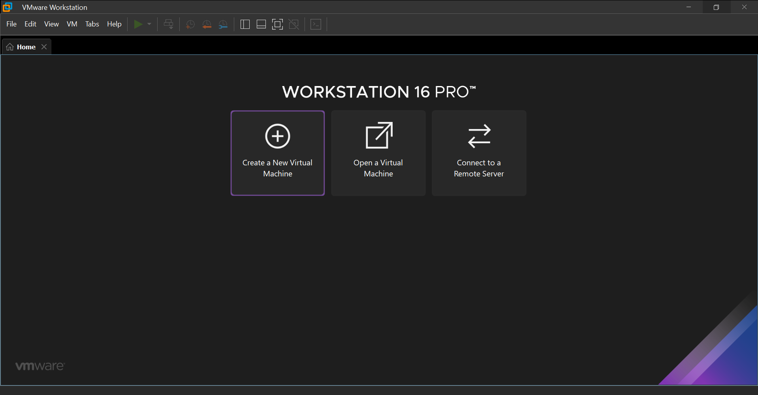

New Virtual Machine Wizard: The New Virtual Machine Wizard will open. Choose the "Typical" configuration option for a standard VM setup, or select "Custom" for advanced configurations.

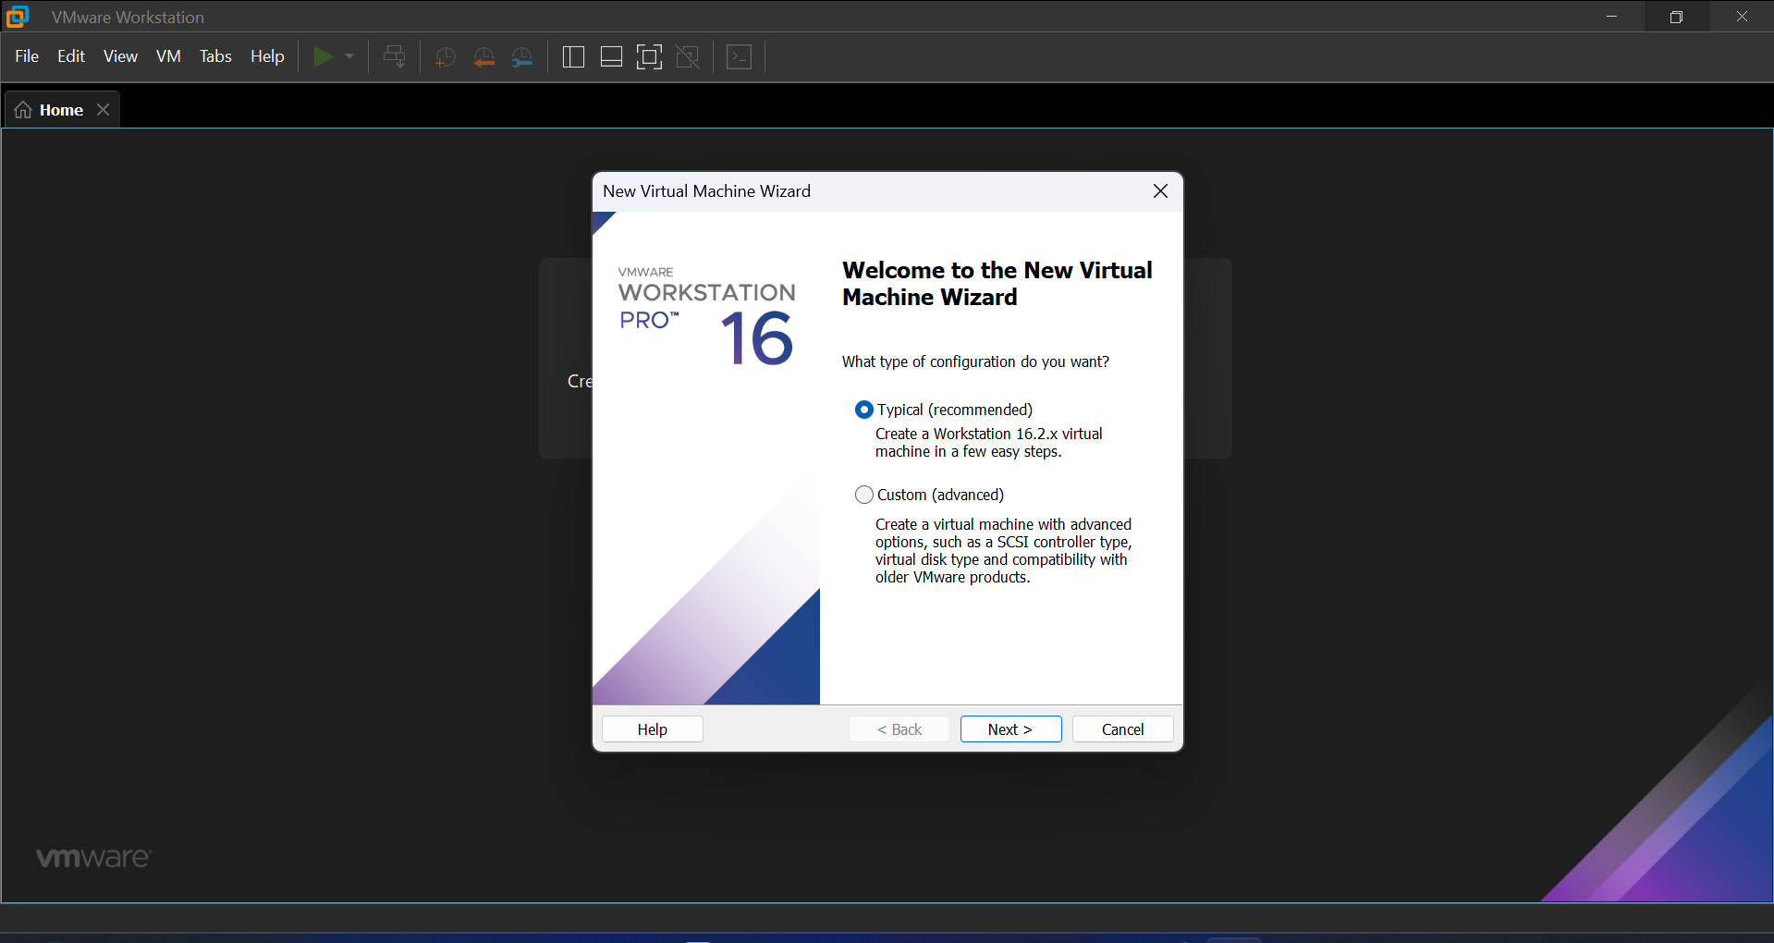

Guest Operating System Installation: Select "Installer disc image file (iso)" and browse to the location of your Windows installation ISO file. Click "Next".

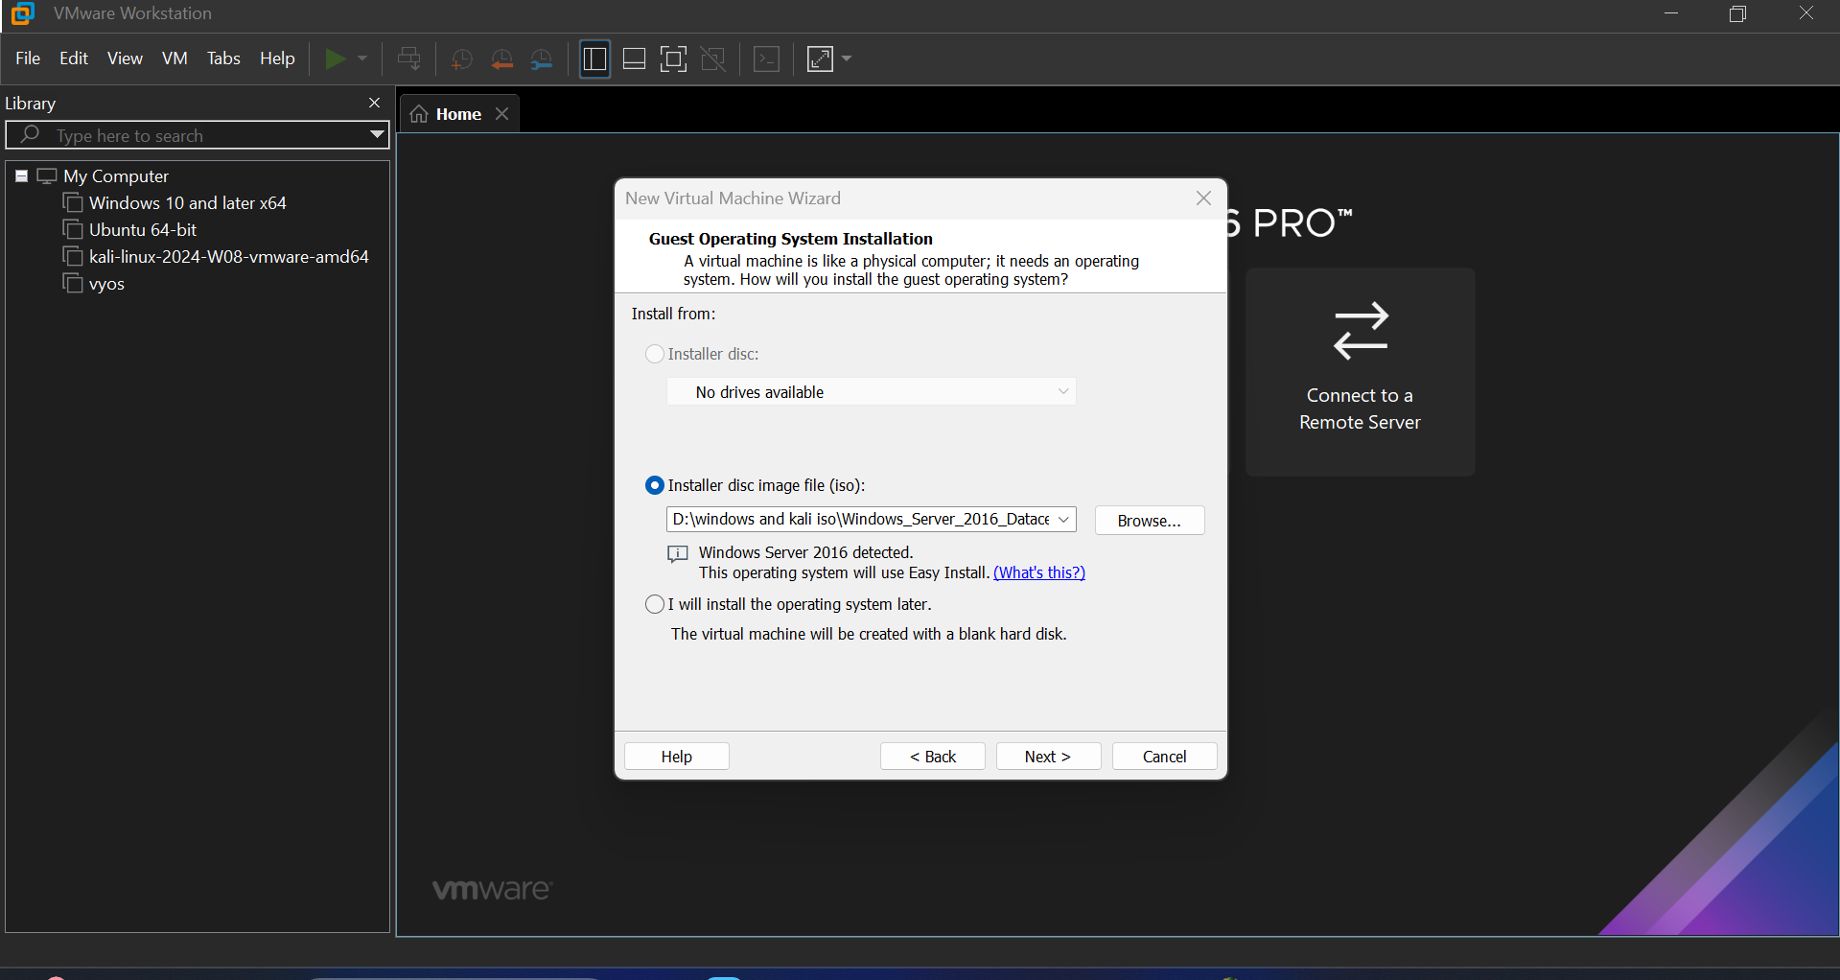

Windows Version Selection: Choose the version of Windows you are installing from the dropdown menu. Click "Next".

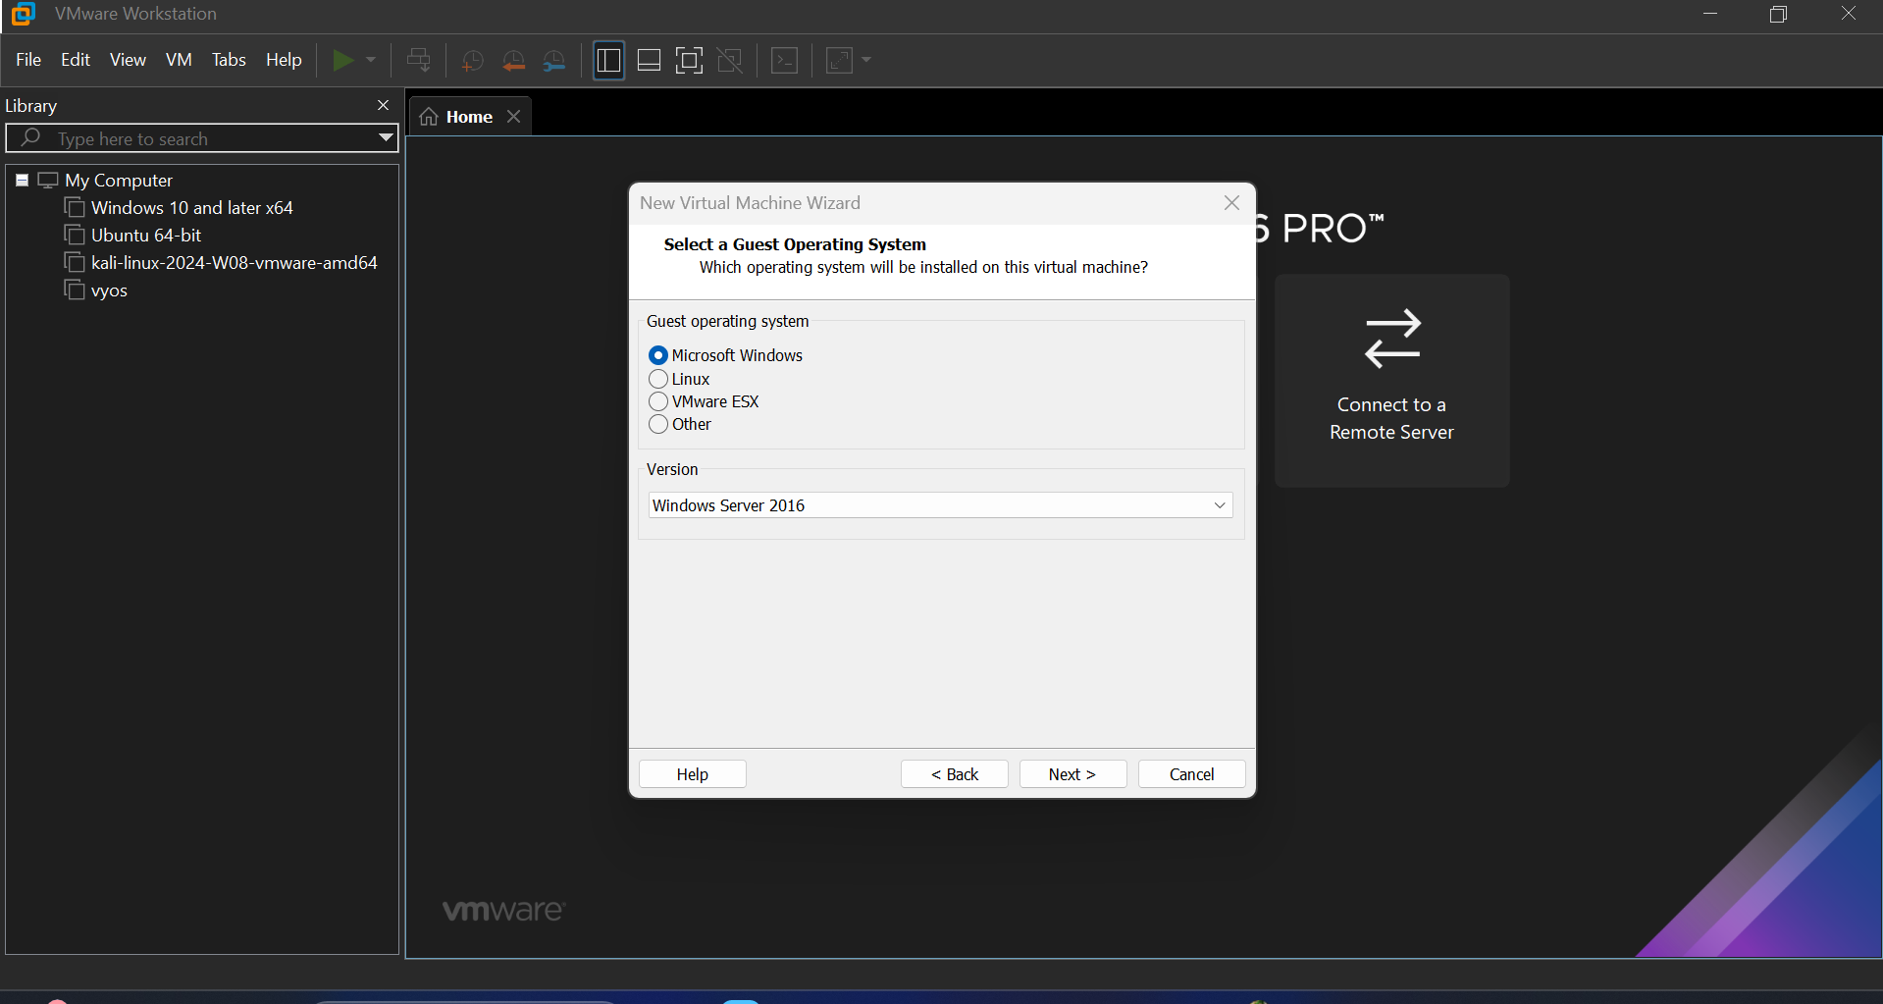

Virtual Machine Name and Location: Enter a name for your virtual machine and choose the location where you want to store the VM files. Click "Next".

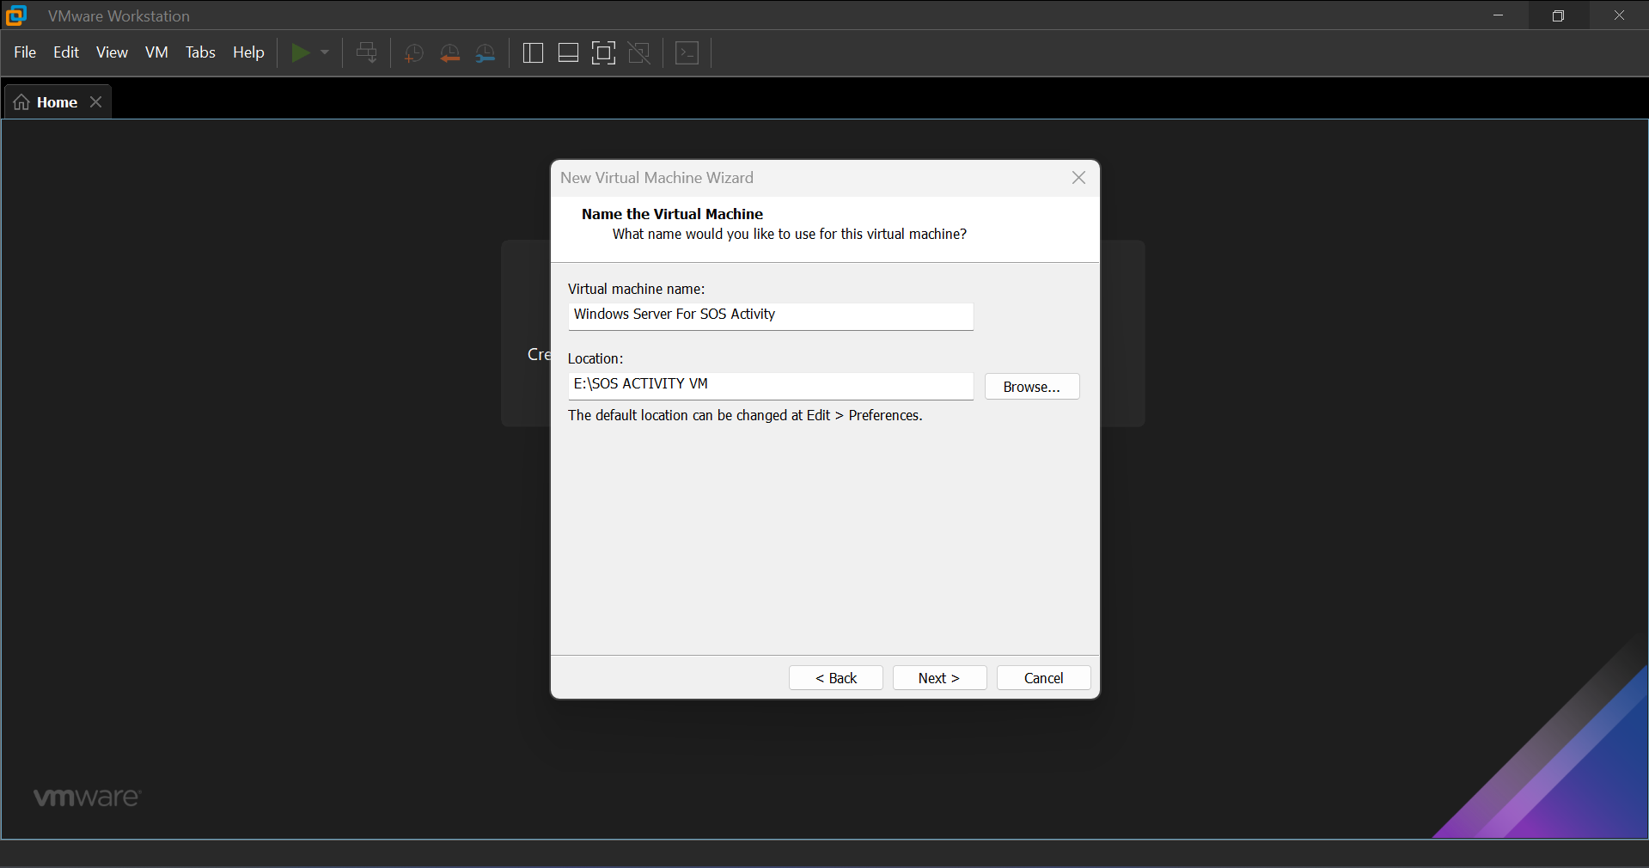

Disk Capacity: Specify the disk size for your VM. The default size is usually sufficient, but you can adjust it as needed. Click "Next".

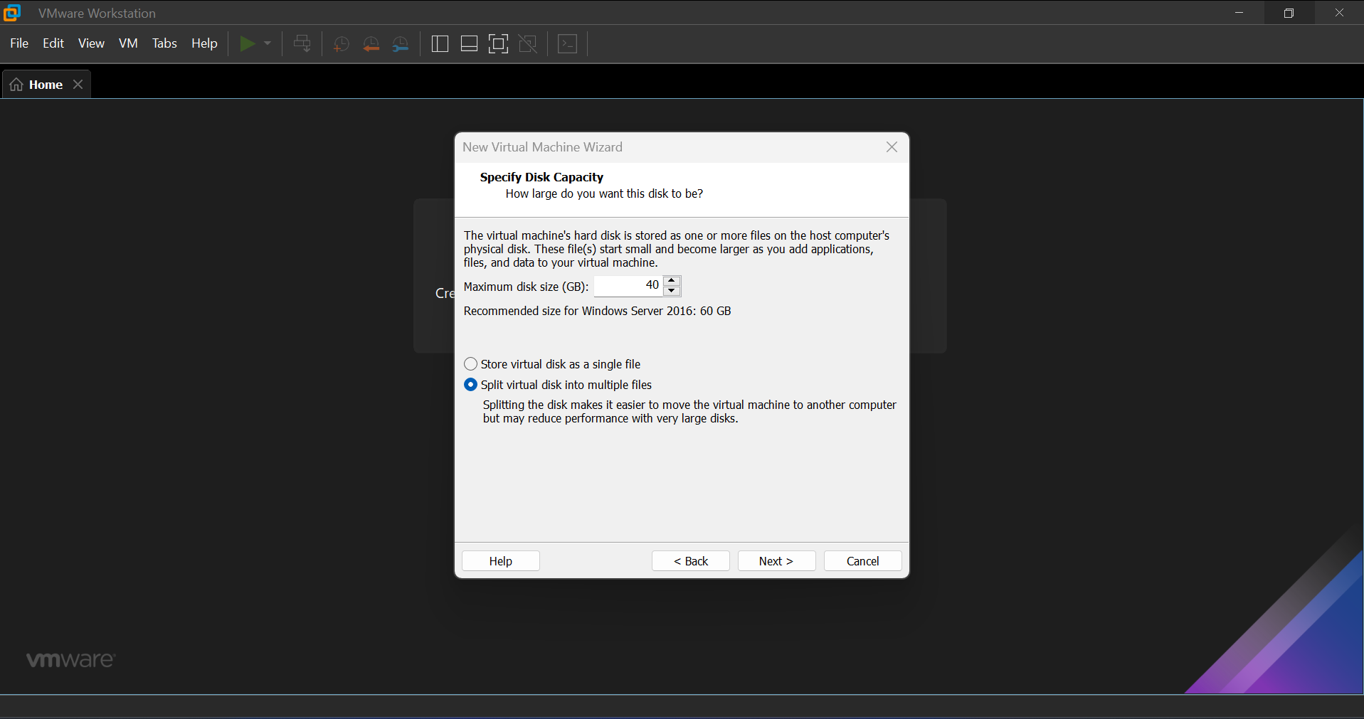

Ready to Create Virtual Machine: Review the settings and click "Finish" to create the VM.

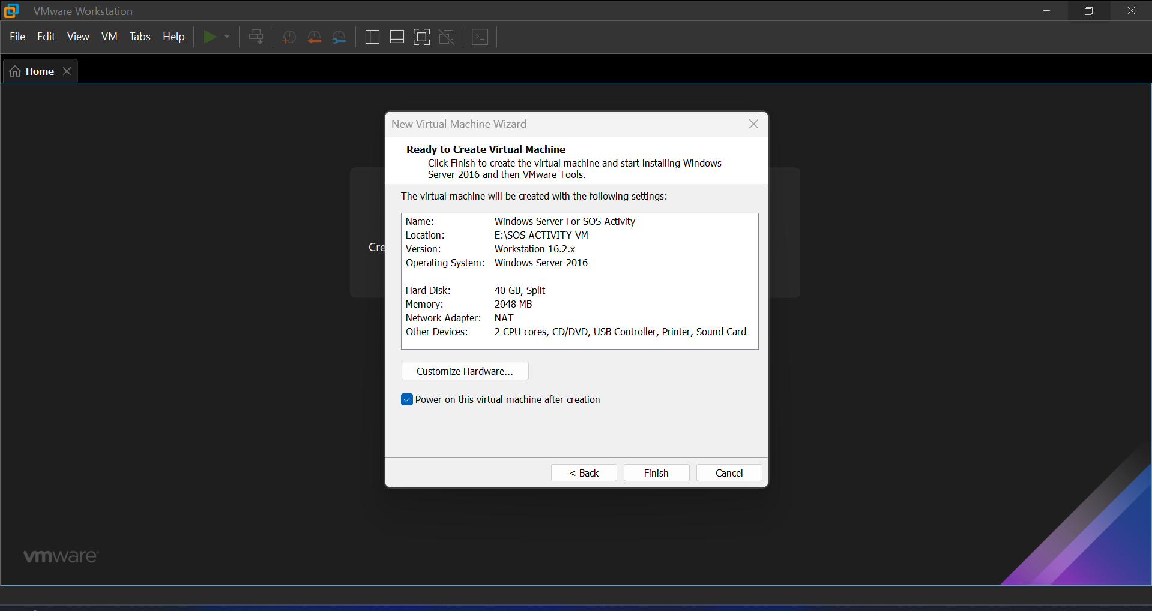

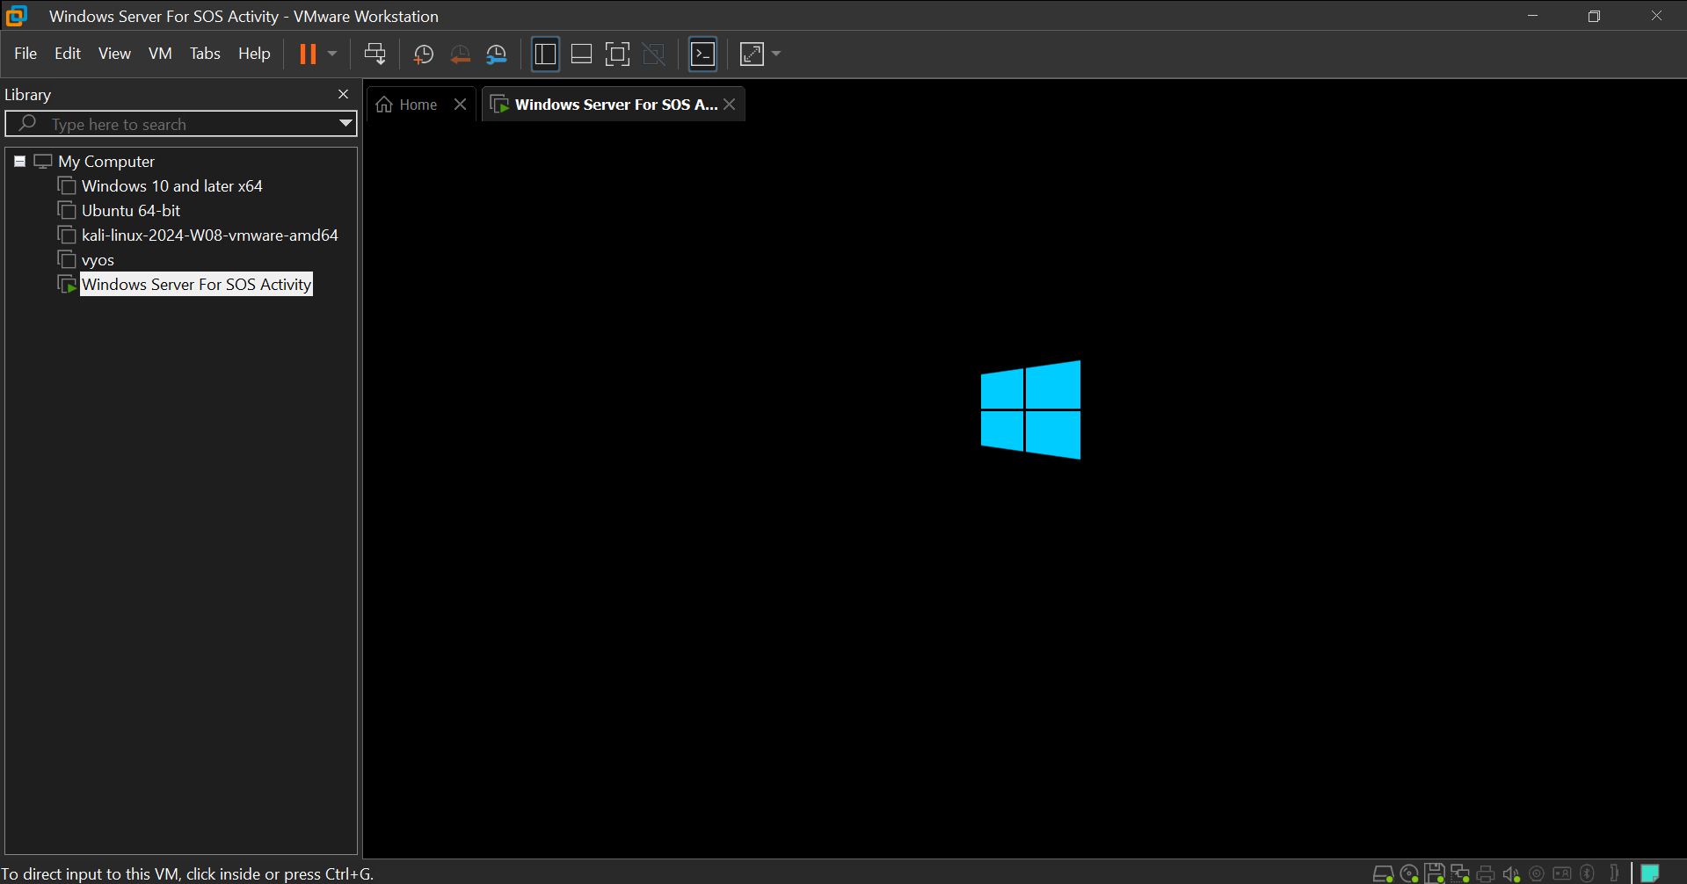

From Removable Devices, enable and connect the CD/DVD (SATA) disk

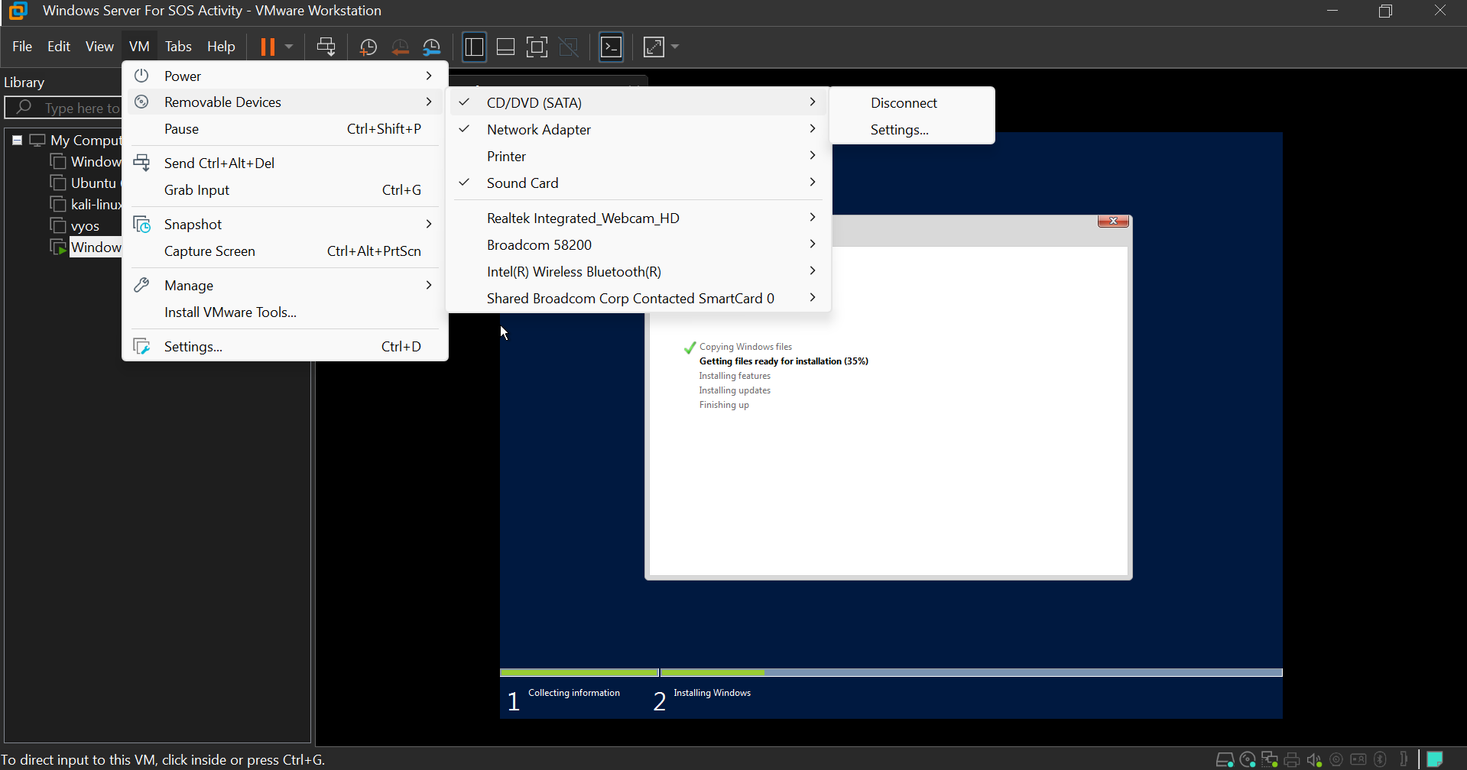

Install Windows: Power on the VM, and it will boot from the Windows installation ISO. Follow the on-screen instructions to install Windows on the virtual machine.

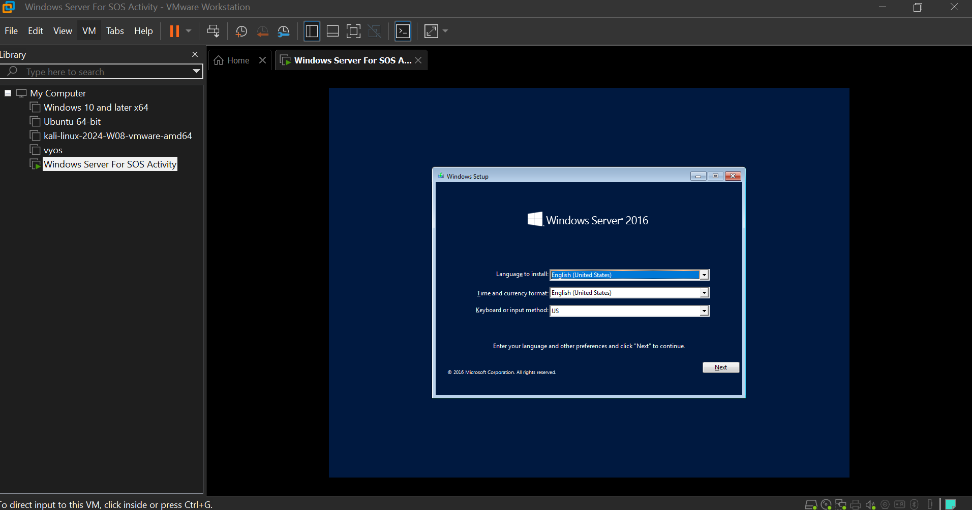

Select the Datacenter edition for Desktop experience (GUI) for the Windows type

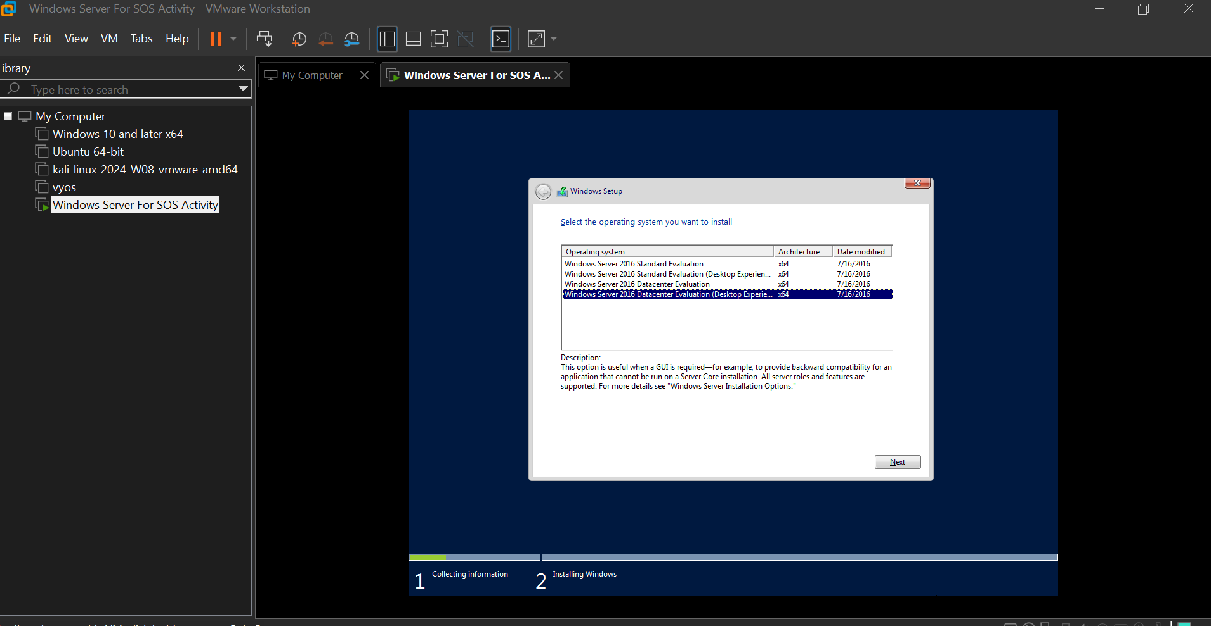

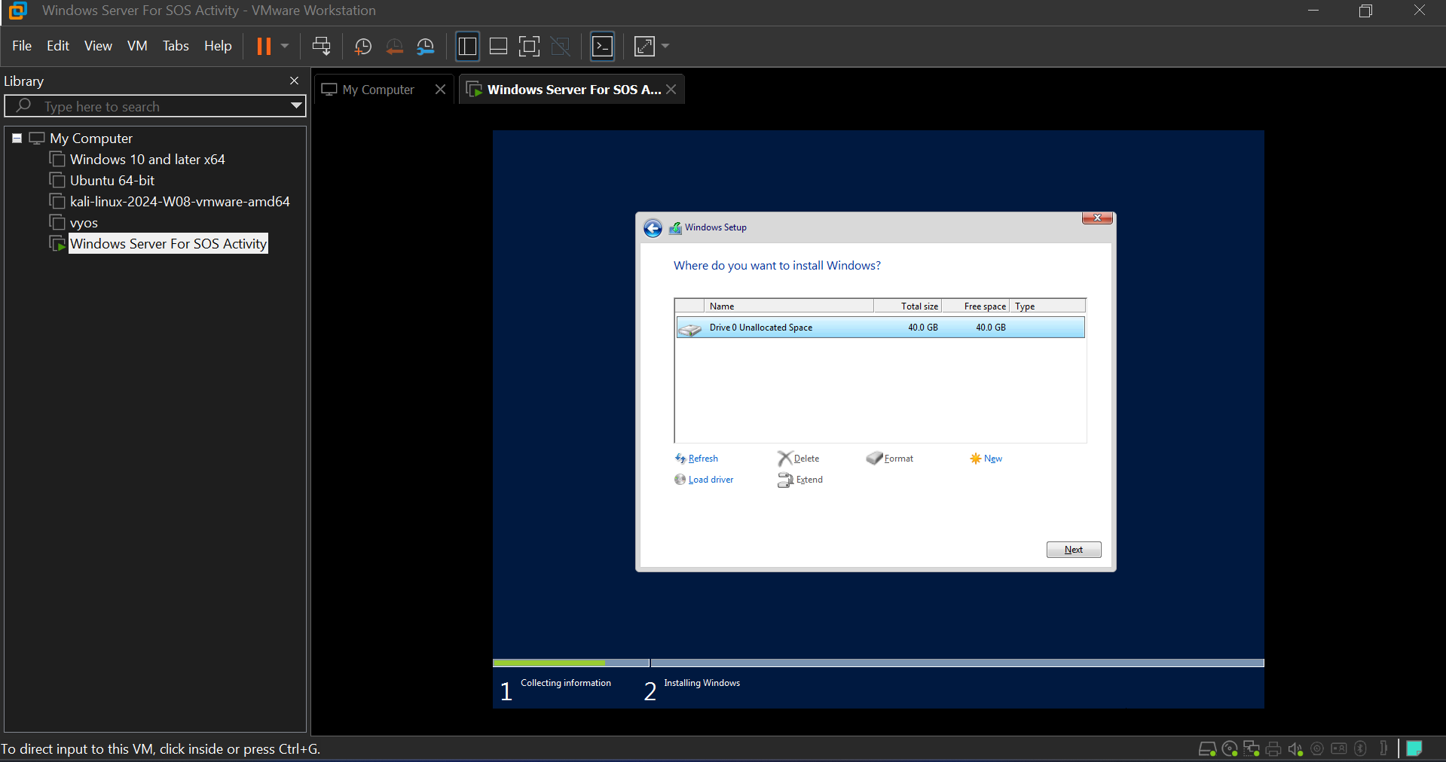

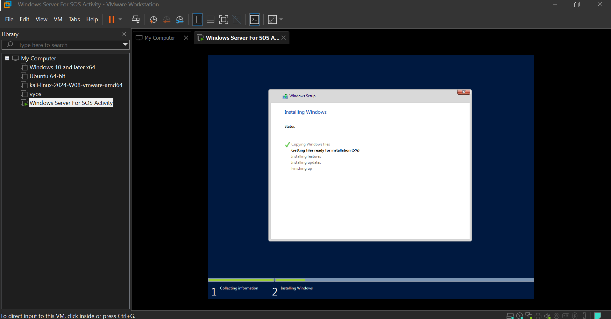

VMware Tools Installation: After Windows installation is complete, install VMware Tools to optimize VM performance and enable features like shared folders and clipboard integration. You can find the VMware Tools installation option in the VMware Workstation menu. (after installation run command D:/setup.exe for isntallation)

**Disk partitioning for drives**

Press WIN+R key and type “diskmgmt.msc” for the disk management wizard.

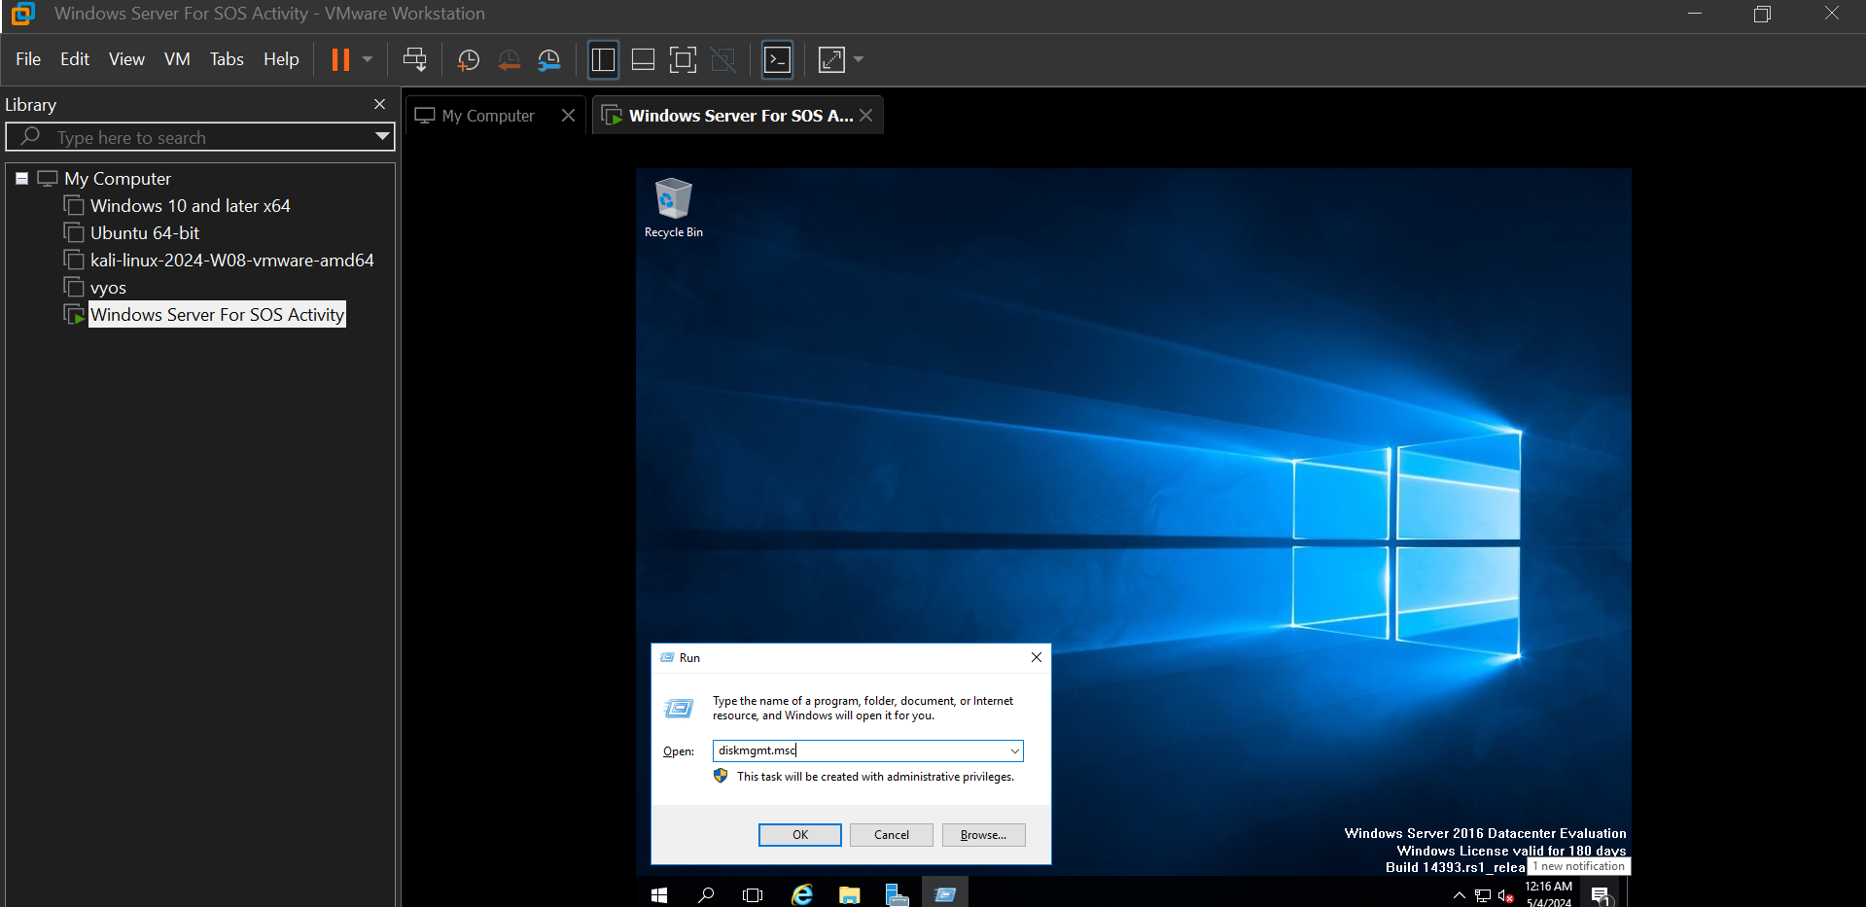

Disk management opens. Now on Drive C right click and select “Shrink Volume”.

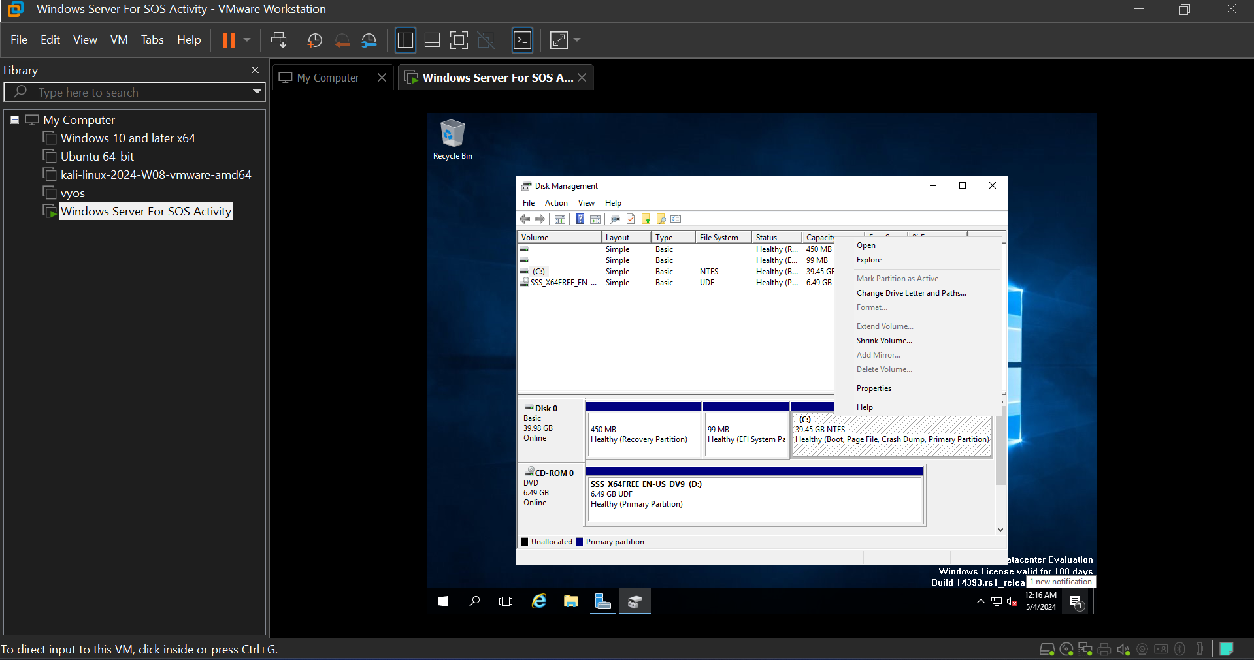

Specify the size (in MB) to shrink. Click Shrink.

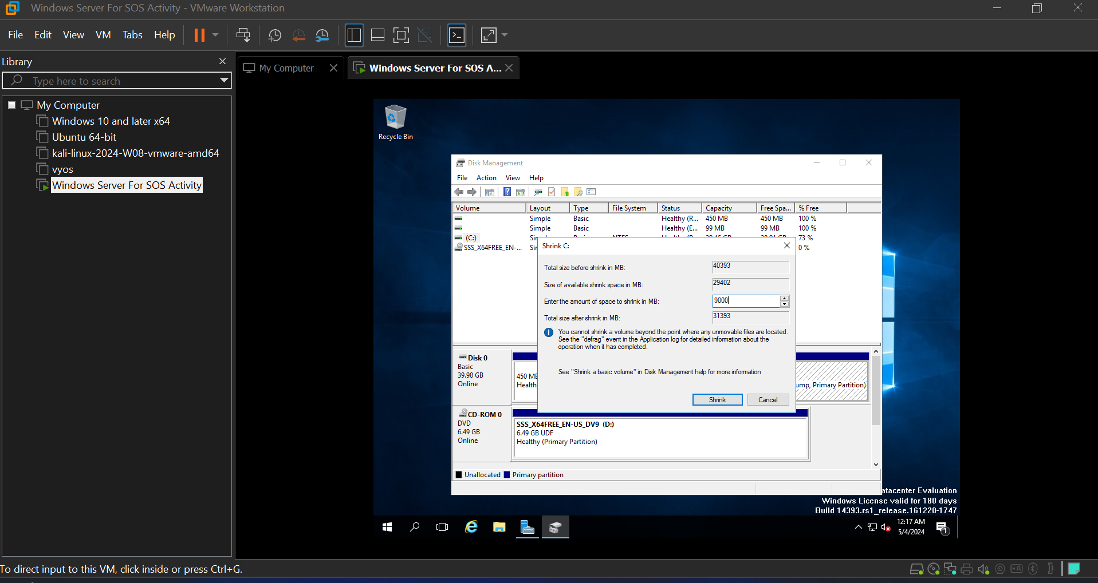

Now on that unallocated space, right click and select “New Simple Volume”.

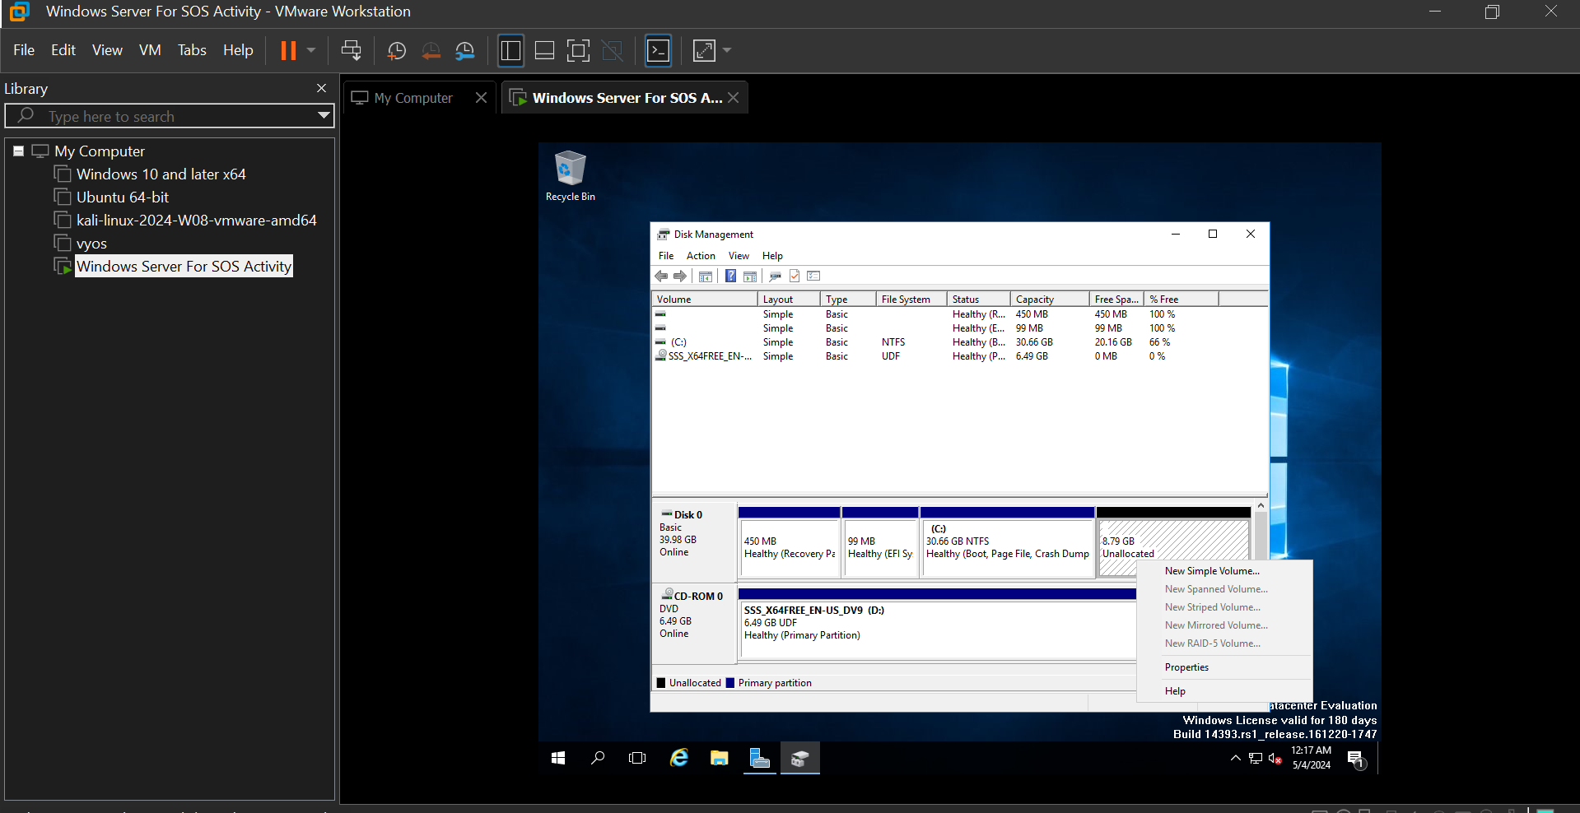

Assign the Drive Letters and the other file system requirements.

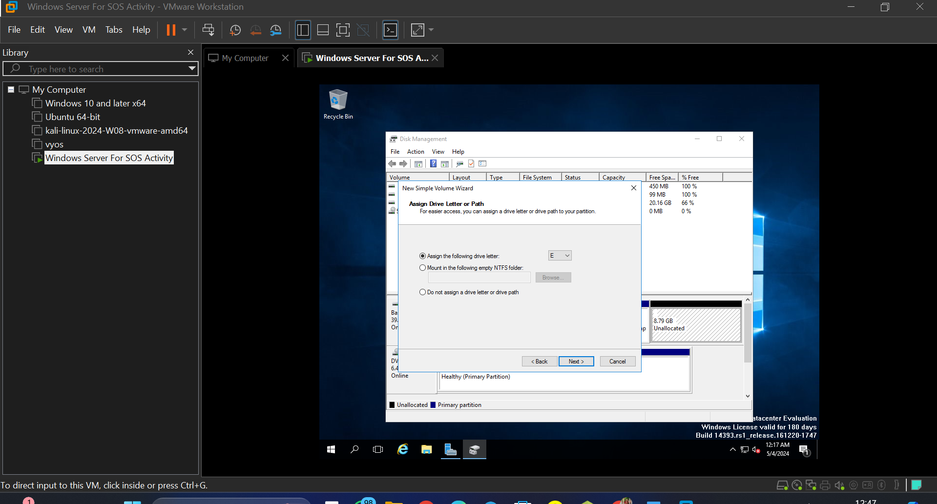

Review the info and click finish.

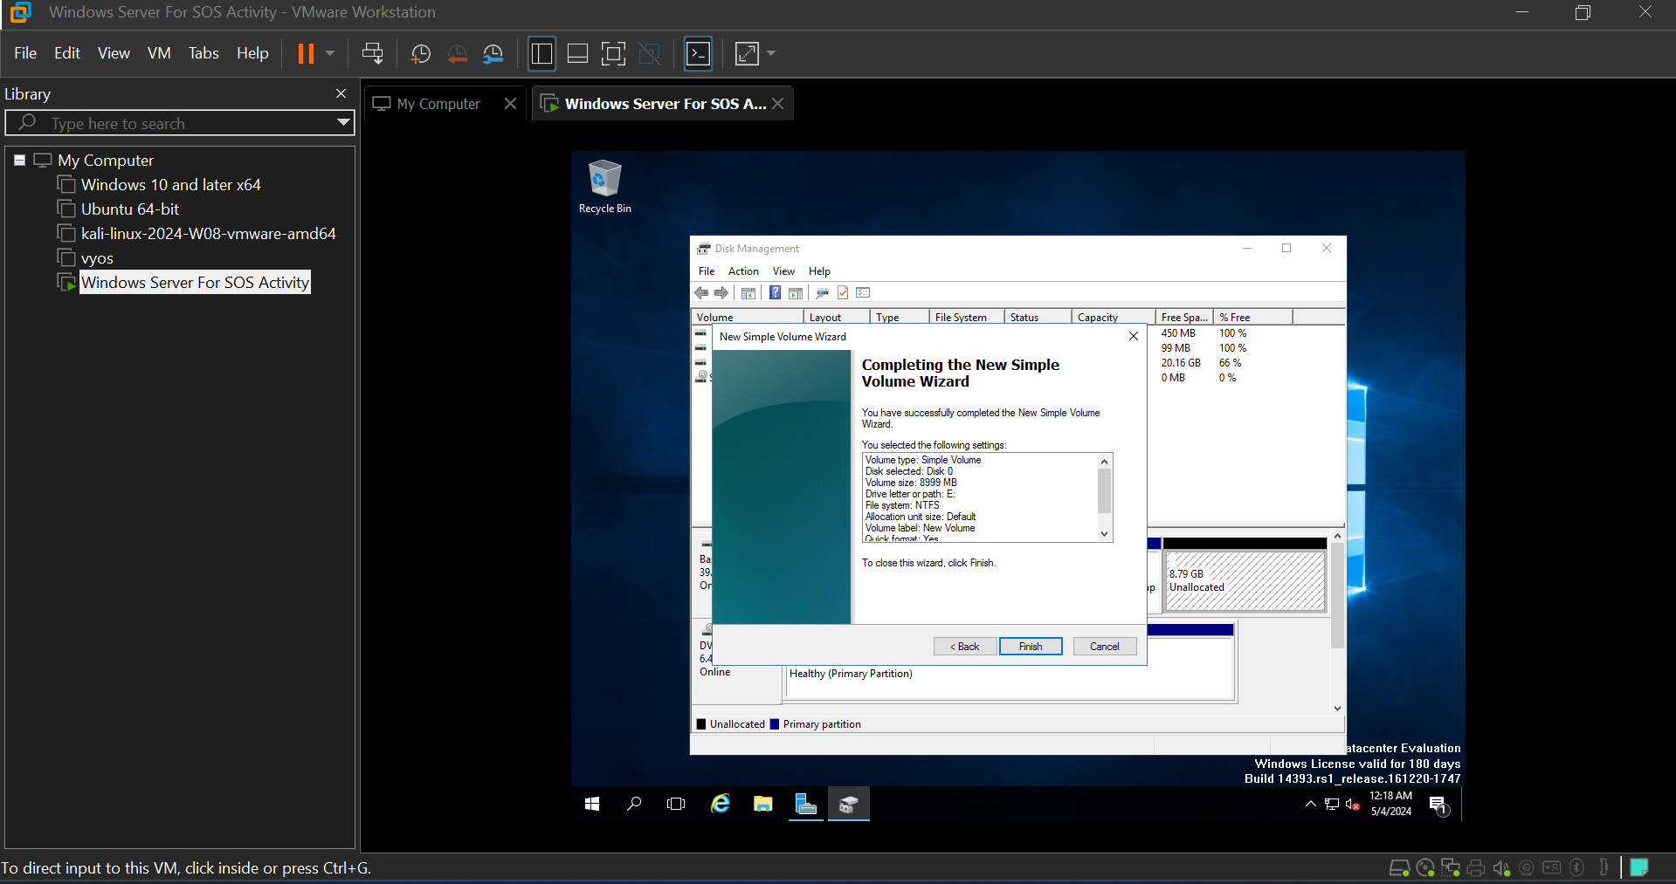

**ADDS Server Configuration**

Launch Server Manager by clicking on the Server Manager icon in the taskbar or by searching for it in the Start menu.

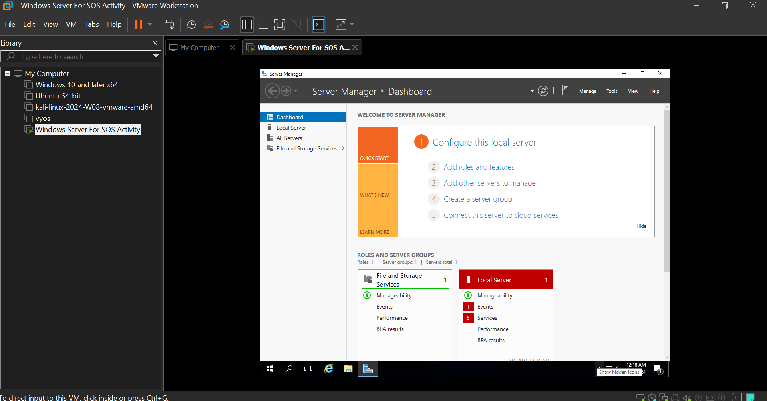

In Server Manager, click on "Manage" from the top menu, and then select "Add Roles and Features" from the dropdown menu. This will open the Add Roles and Features Wizard.

Click on "Next" on the Before you begin page.

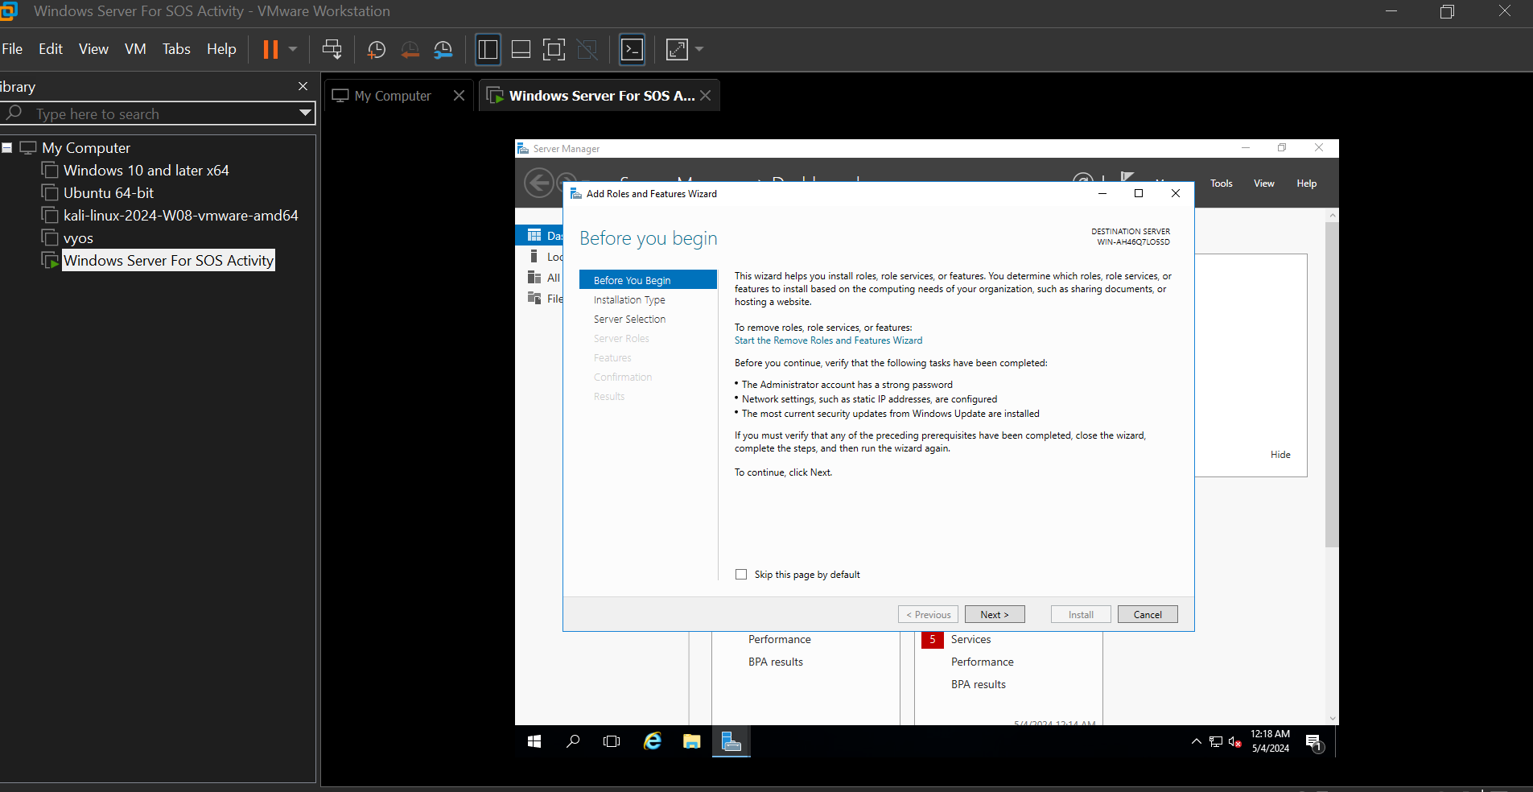

Select "Role-based or feature-based installation" and click on "Next."

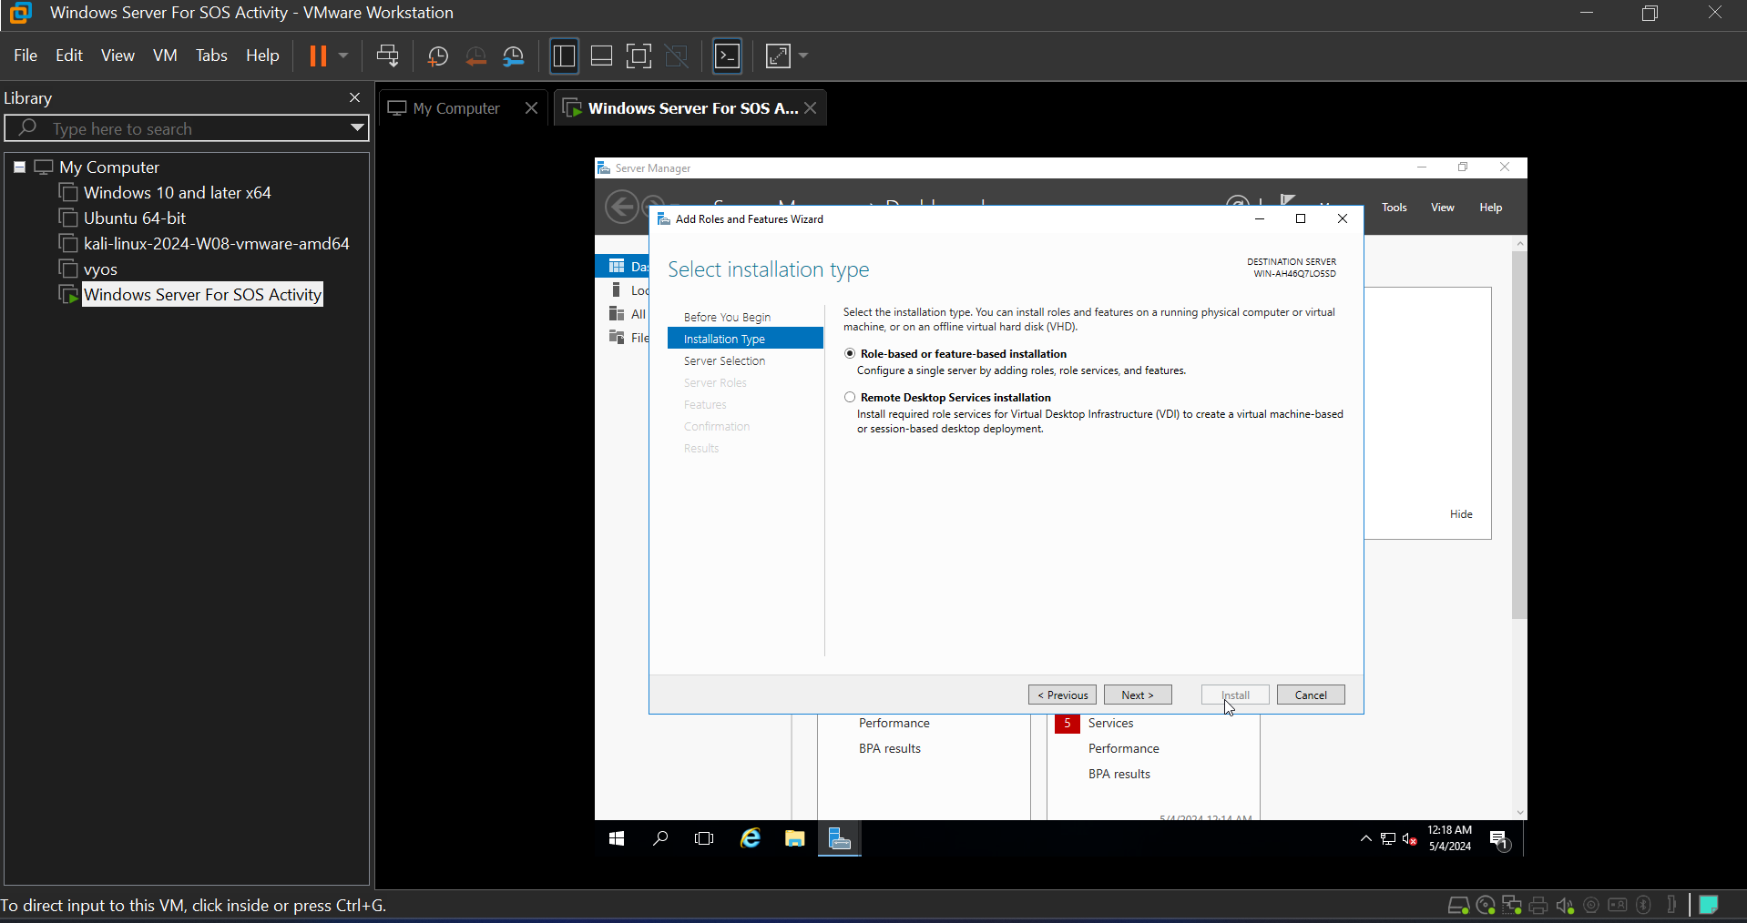

Choose the server where you want to install the AD DS role and click on "Next."

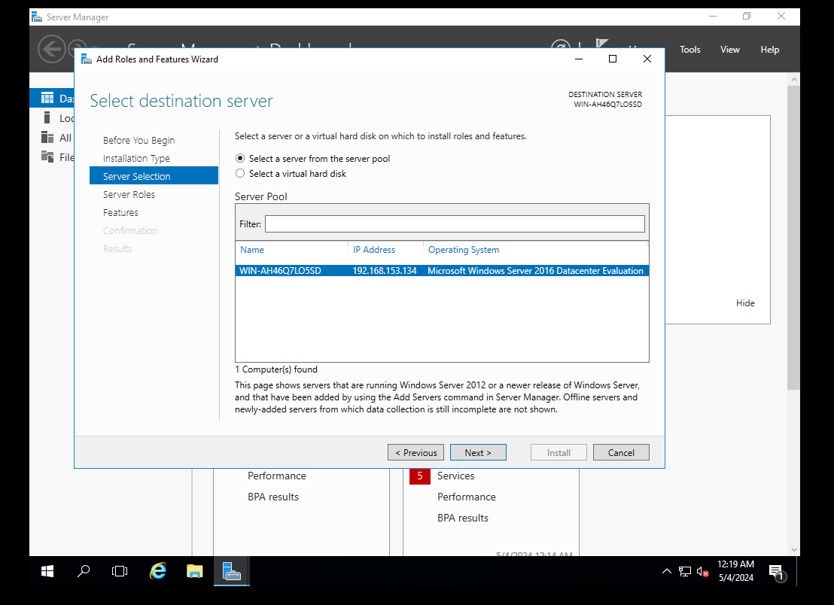

In the Server Roles section, select "Active Directory Domain Services." A pop-up window will appear asking if you want to add additional features. Click on "Add Features" and then click on "Next."

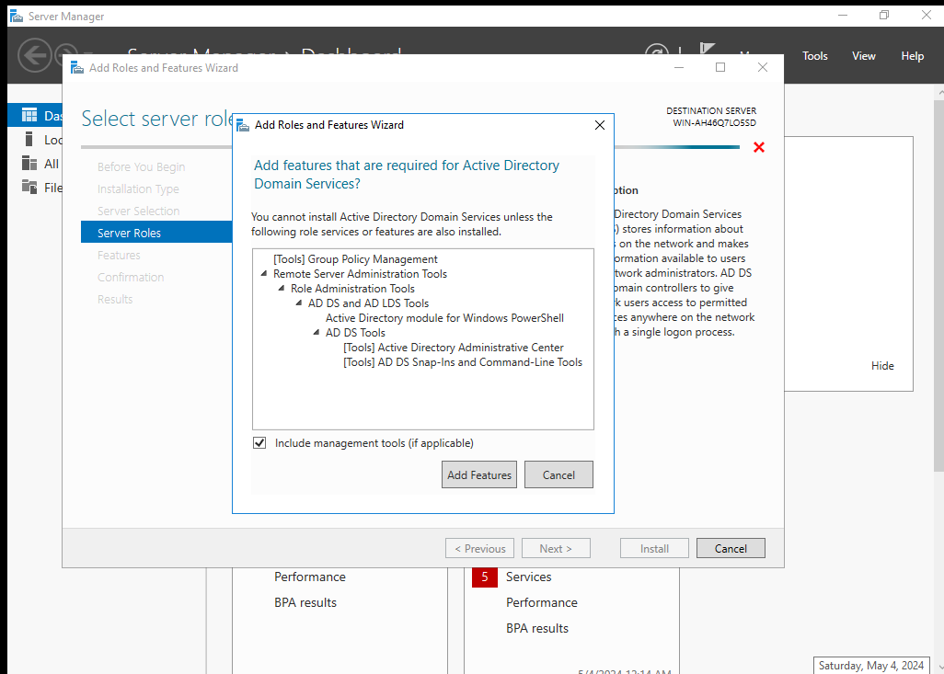

Review the information on the Active Directory Domain Services page, and then click on "Next."

On the Features page, click on "Next" (there are no additional features required).

On the Active Directory Domain Services page, read the information and then click on "Next."

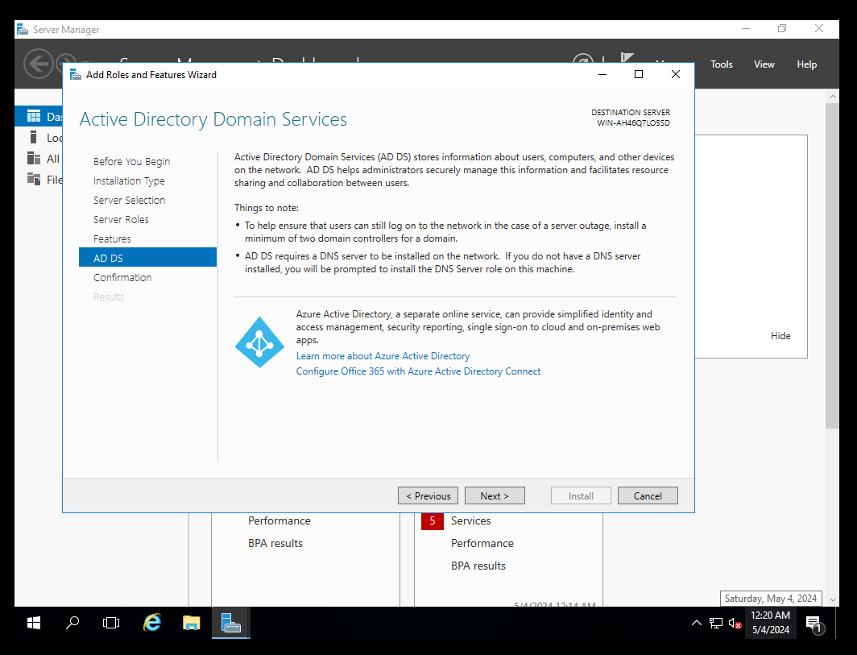

Review the information on the Confirmation page, and then click on "Install" to begin the installation process.

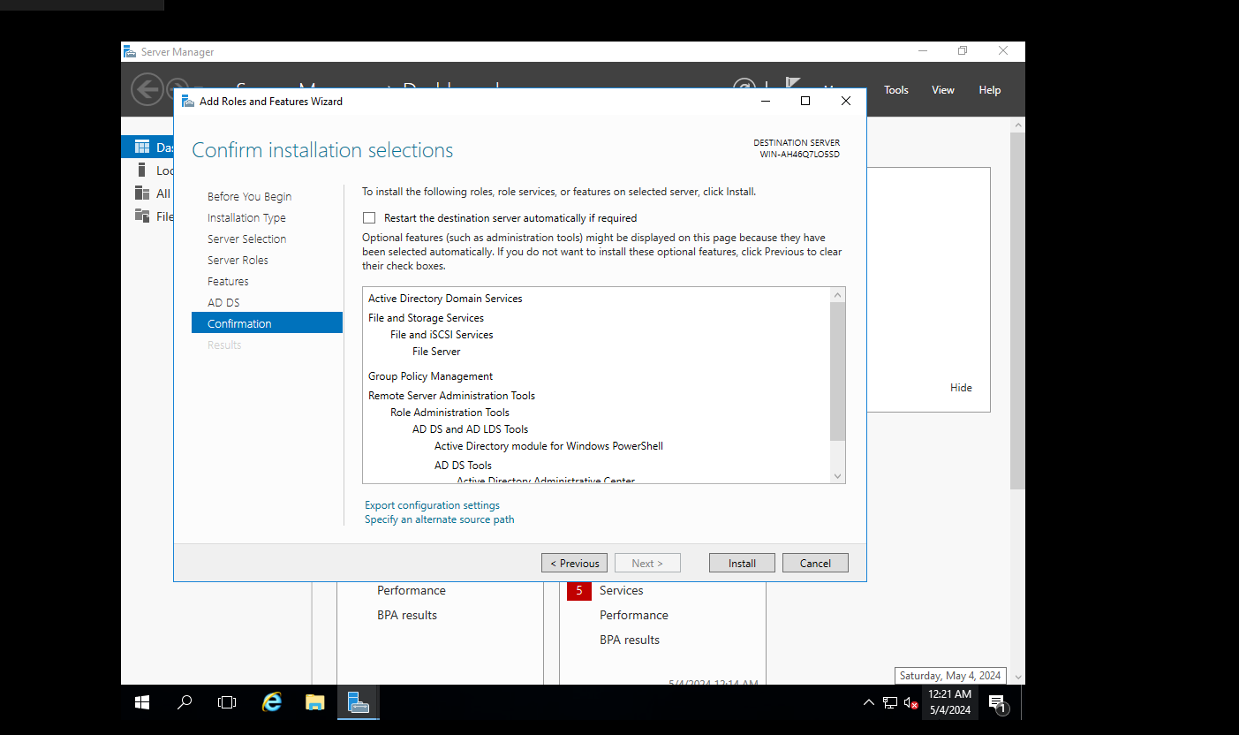

Once the installation is complete, click on "Close" to exit the wizard.

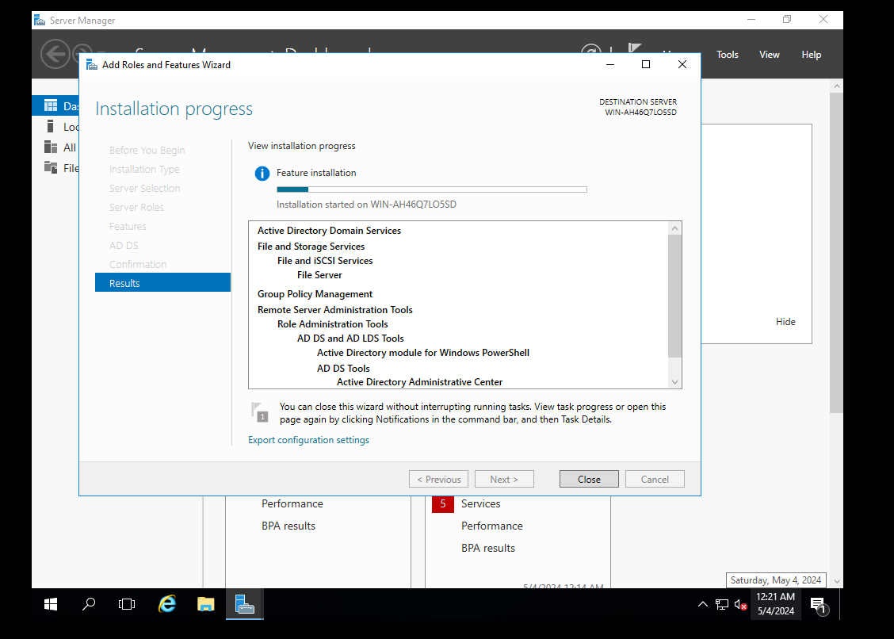

After installing the Active Directory Domain Services role using Server Manager, a notification will appear in the Server Manager dashboard. Click on "Promote this server to a domain controller" in the notification.

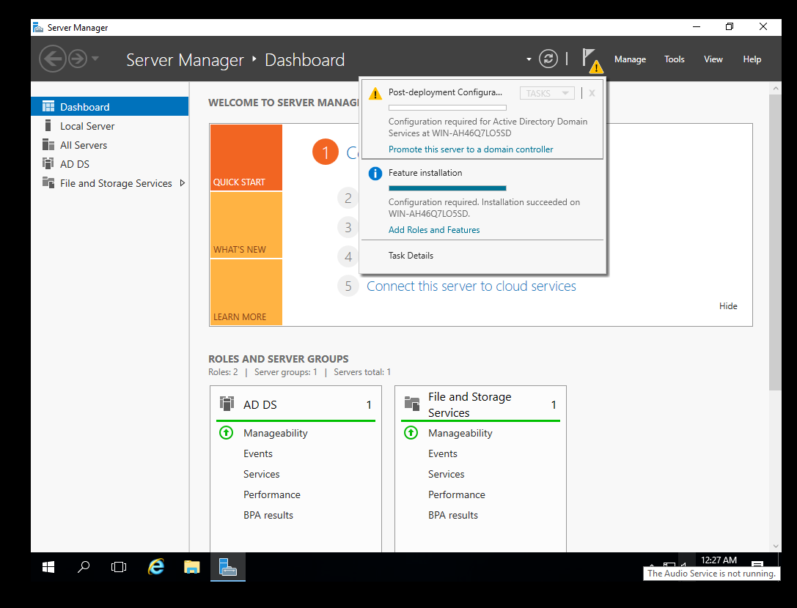

In the Active Directory Domain Services Configuration Wizard, select "Add a new forest" if you are creating a new domain, or select "Add a domain controller to an existing domain" if you are adding a domain controller to an existing domain. Click on "Next."

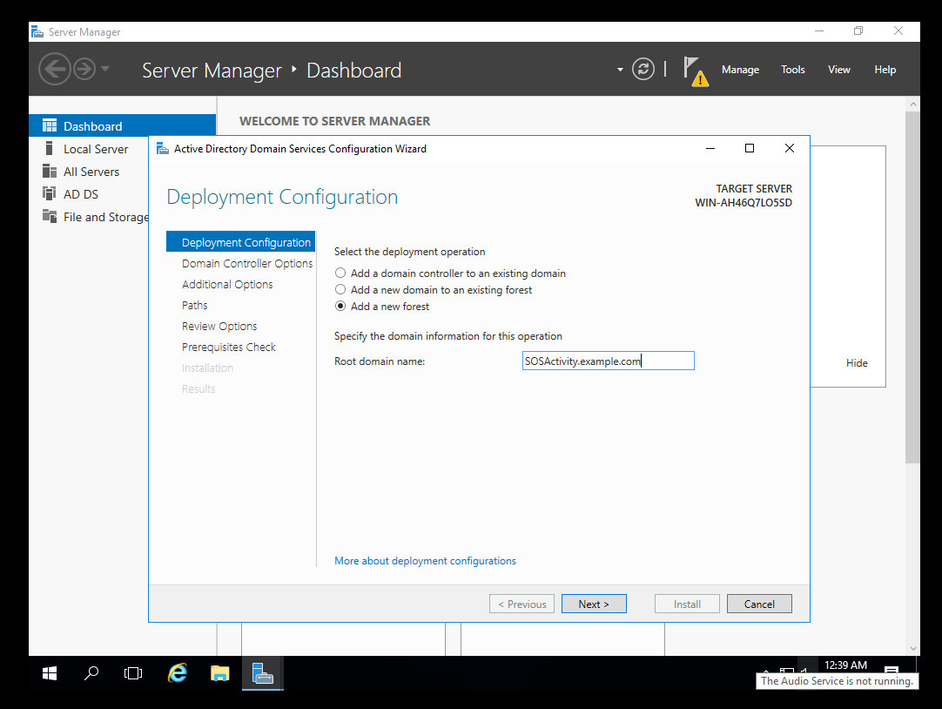

Enter the root domain name for the forest and click on "Next."

Specify the forest and domain functional levels and set a Directory Services Restore Mode (DSRM) password. Click on "Next."

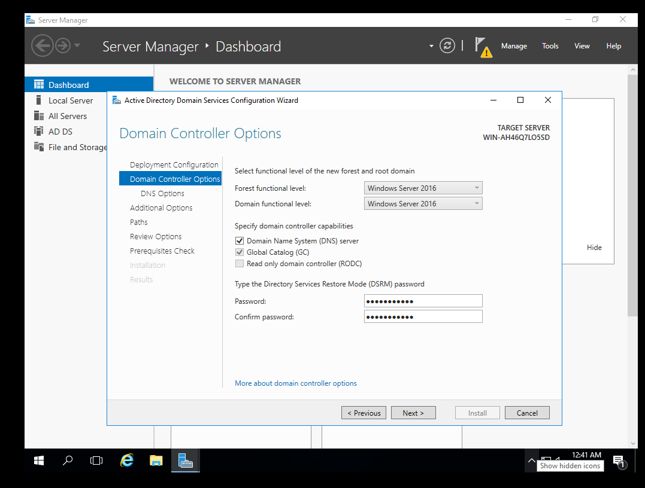

Additional Options page, you can configure additional options such as the NetBIOS domain name and the paths for the database, log files, and SYSVOL. Review the information and click on "Next."

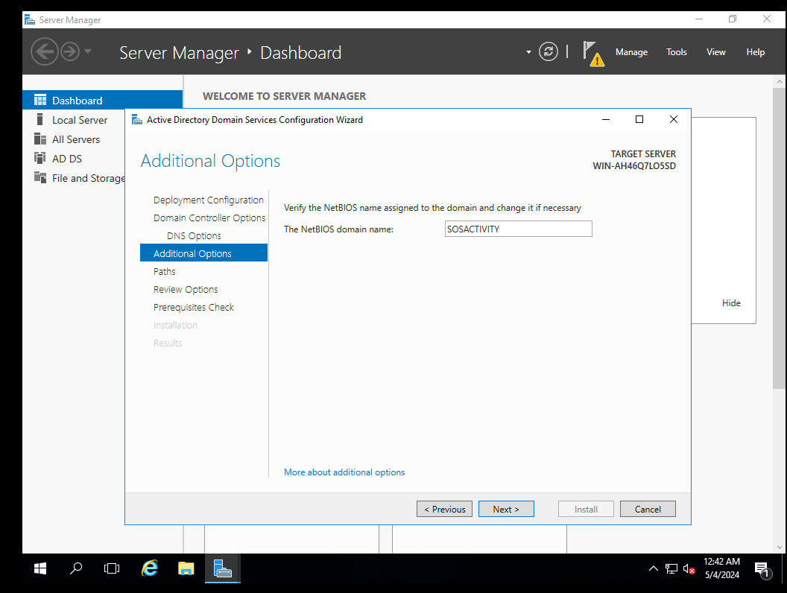

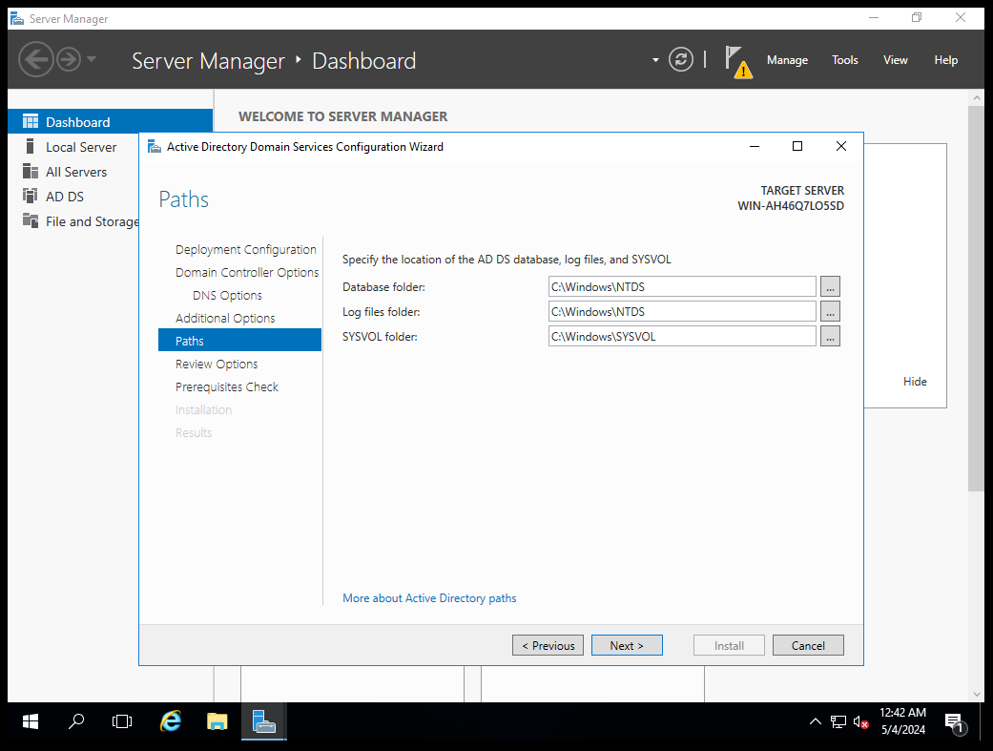

Review the information on the Review Options page, and then click on "Next" to start the prerequisite check.

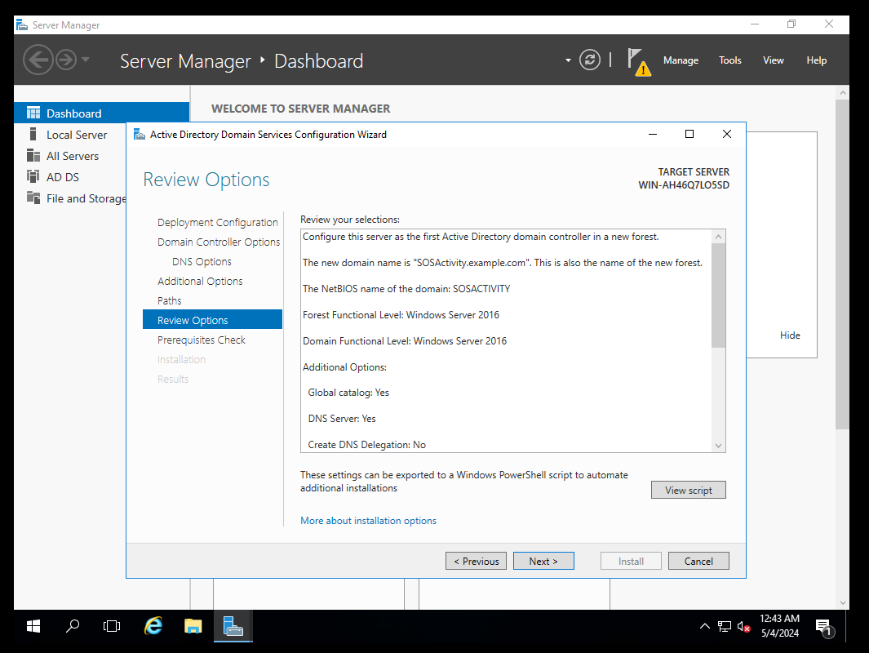

Once the prerequisite check is complete, review the results and click on "Install" to begin the installation process.

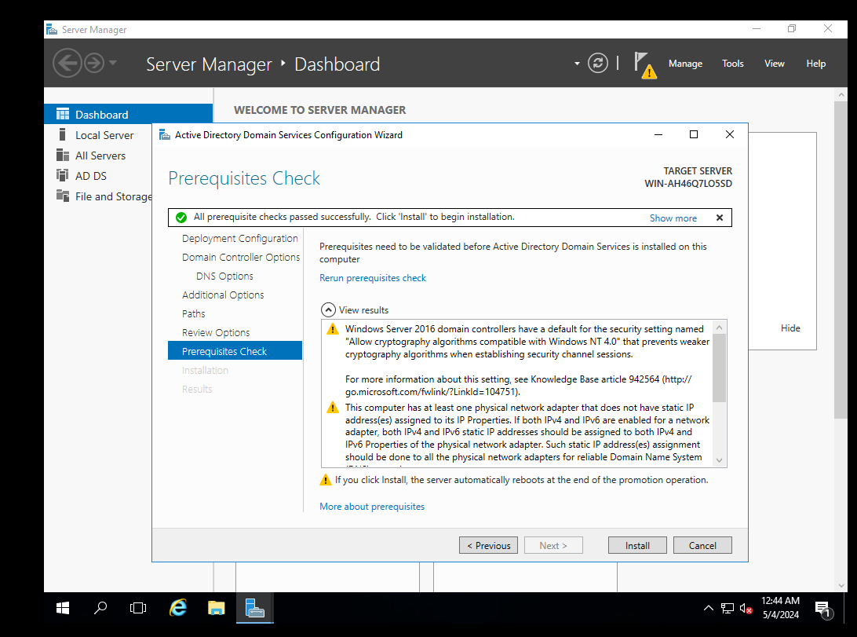

After the installation is complete, the server will automatically restart, and you will have successfully installed and configured the Active Directory Domain Services role.

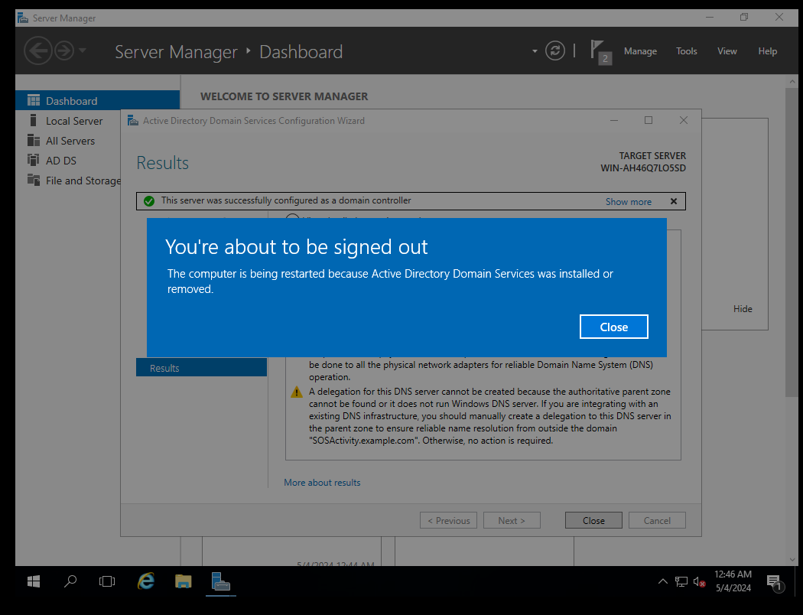

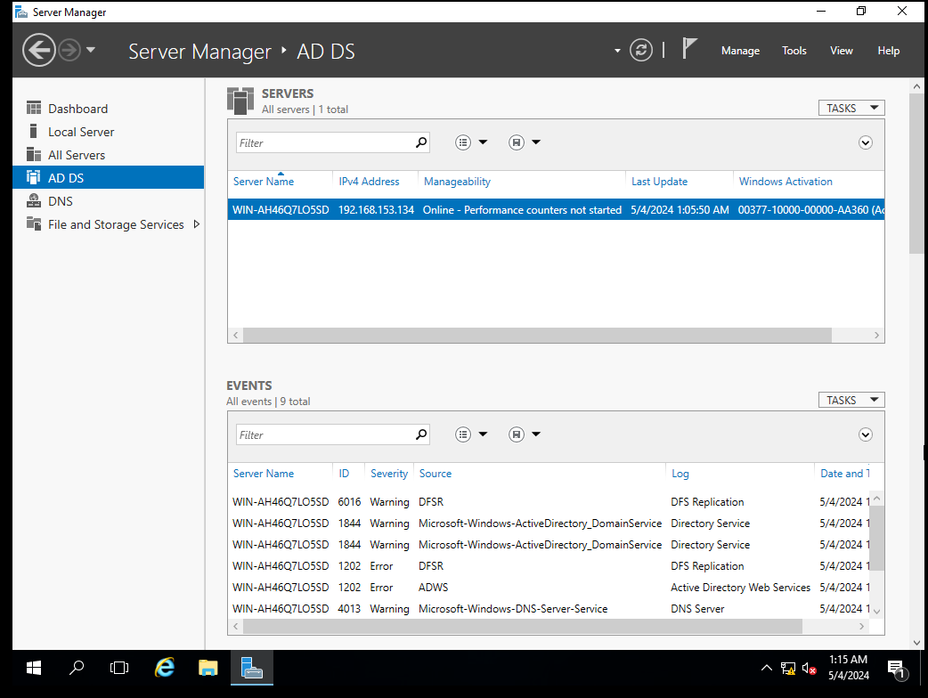

**Adding users in the domain**

Open Active Directory Users and Computers by clicking Start Administrative Tools Active Directory Users And Computers.

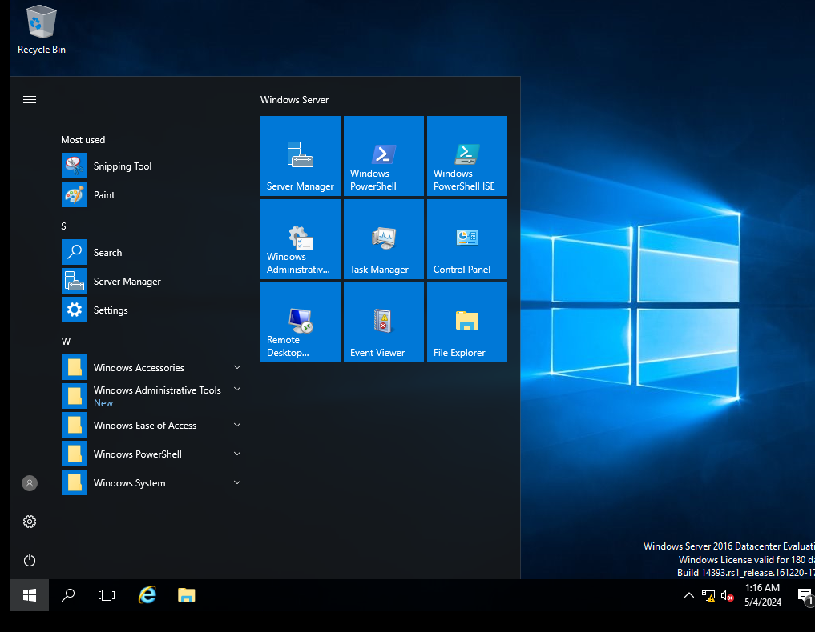

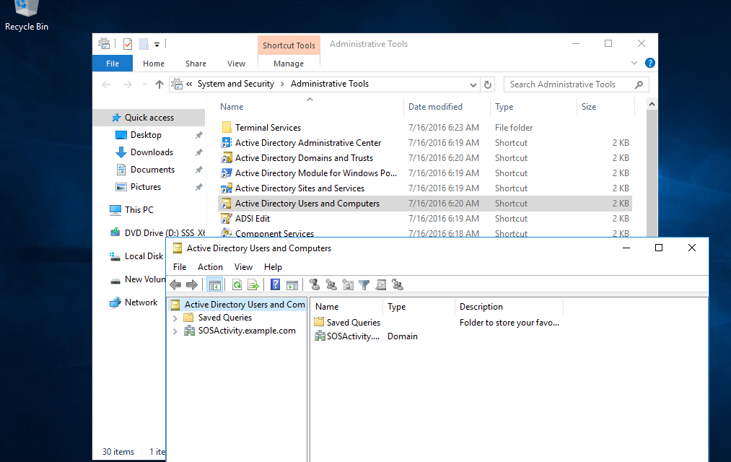

Right-click the OU and select New User. Fill the required info (make users in SOS1 and SOS2 OUs)

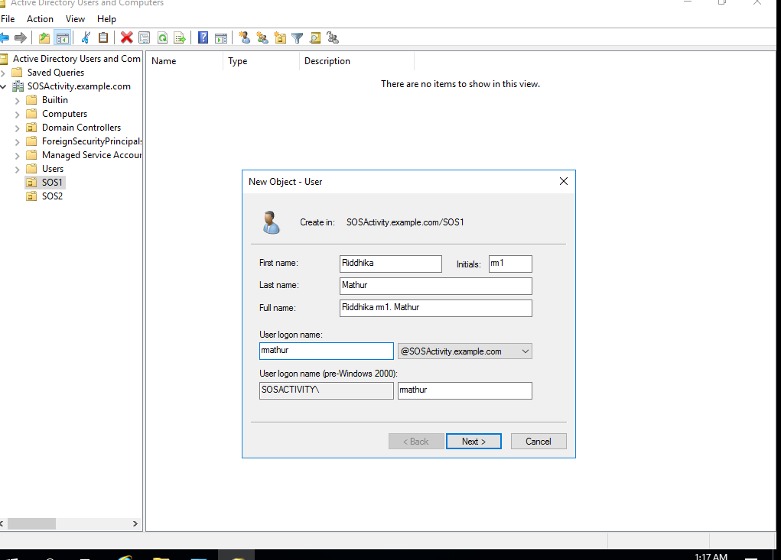

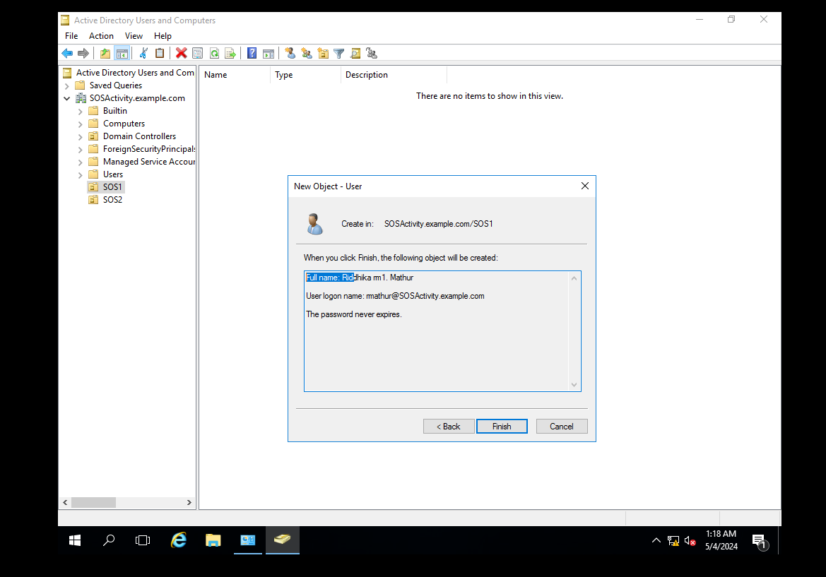

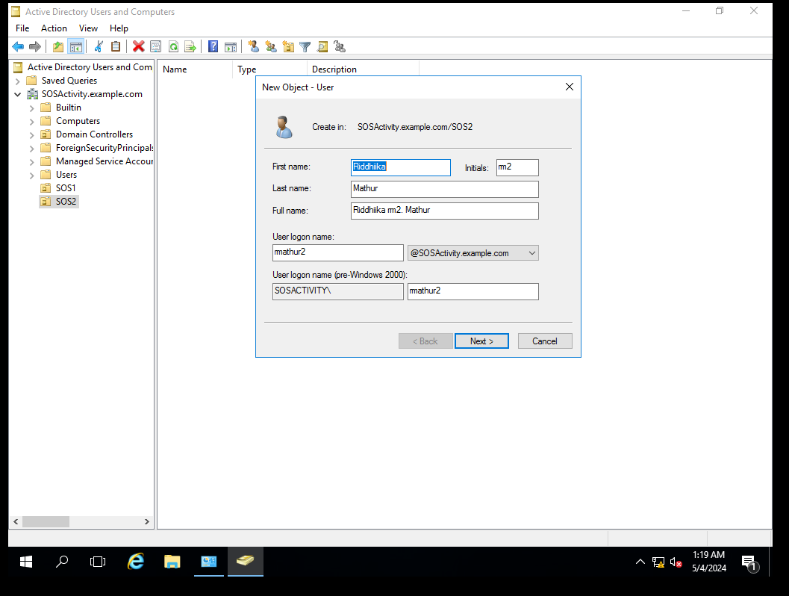

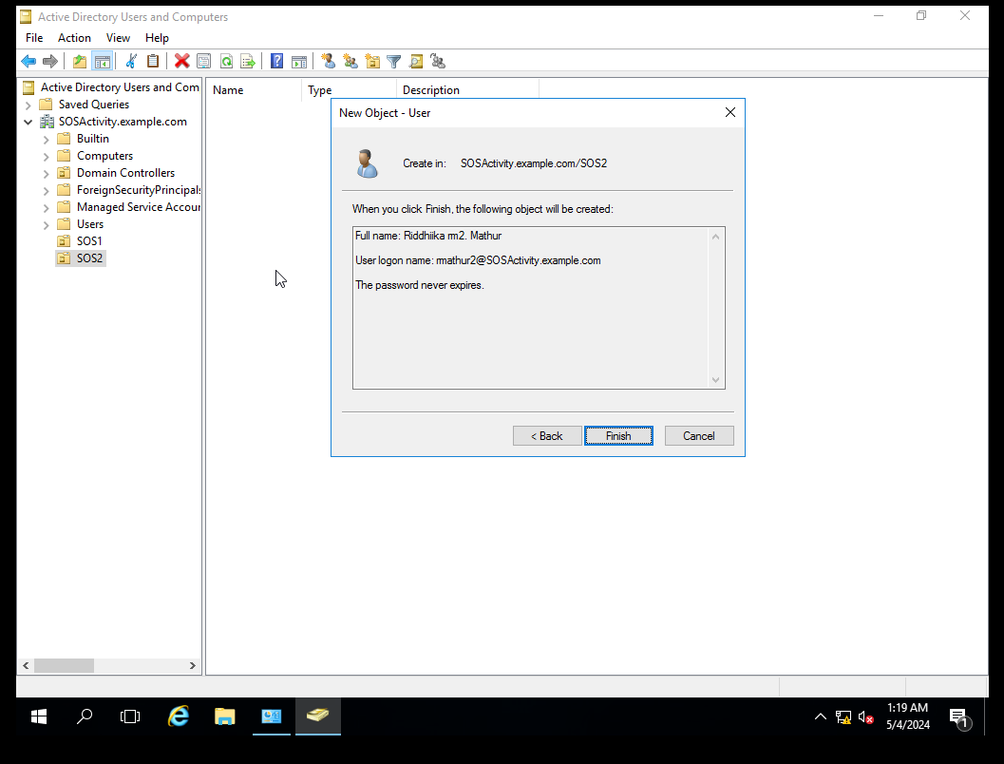

To create a new group, open the Active Directory Users and Computers snap-in. Click the OU

where the group is going to reside. Right-click and choose New and then Group. After you

create the group, just click the Members tab and choose Add. Add the users you want to reside in that group, and that’s all there is to it.

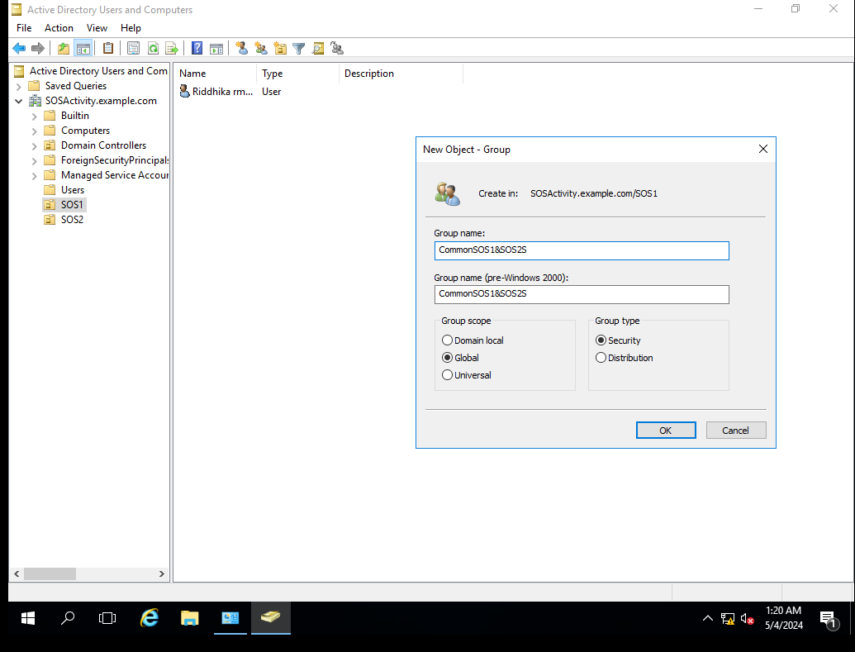

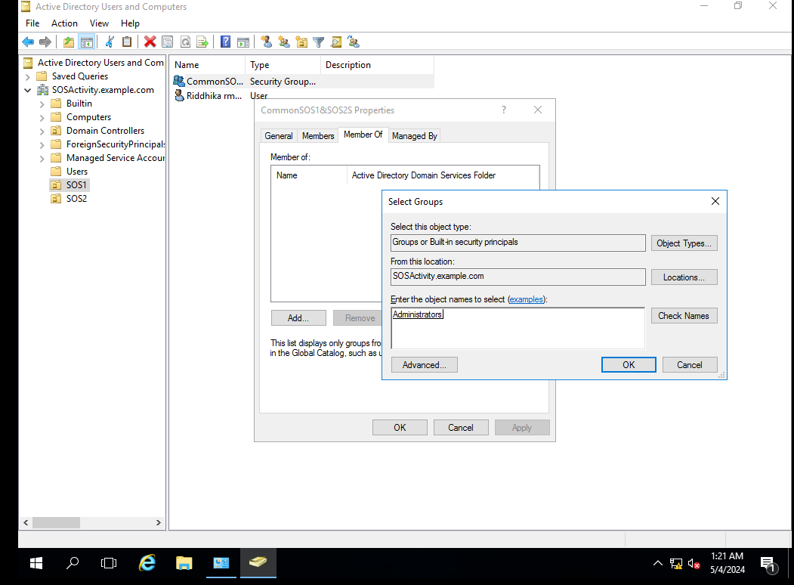

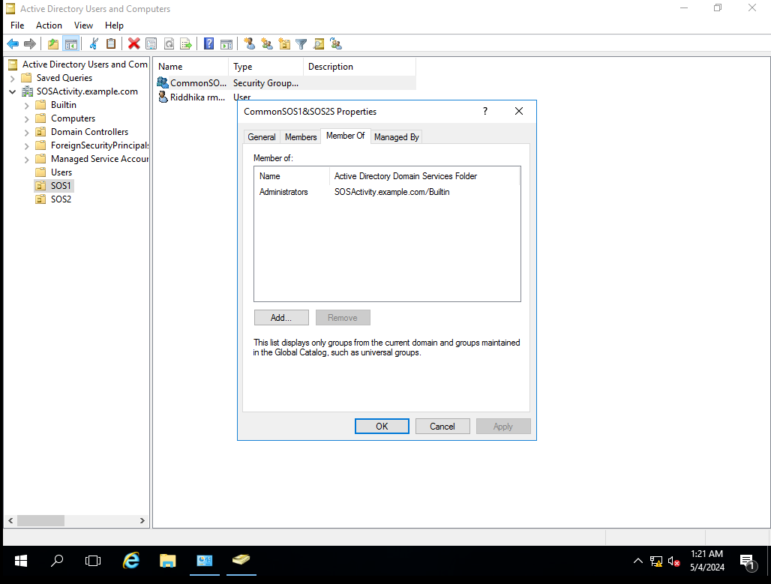

**In windows vm enable NFS client feature**

- Open Server Manager.

- Click on "Manage" and select "Add Roles and Features."

- Proceed with the wizard, selecting "Role-based or feature-based installation."

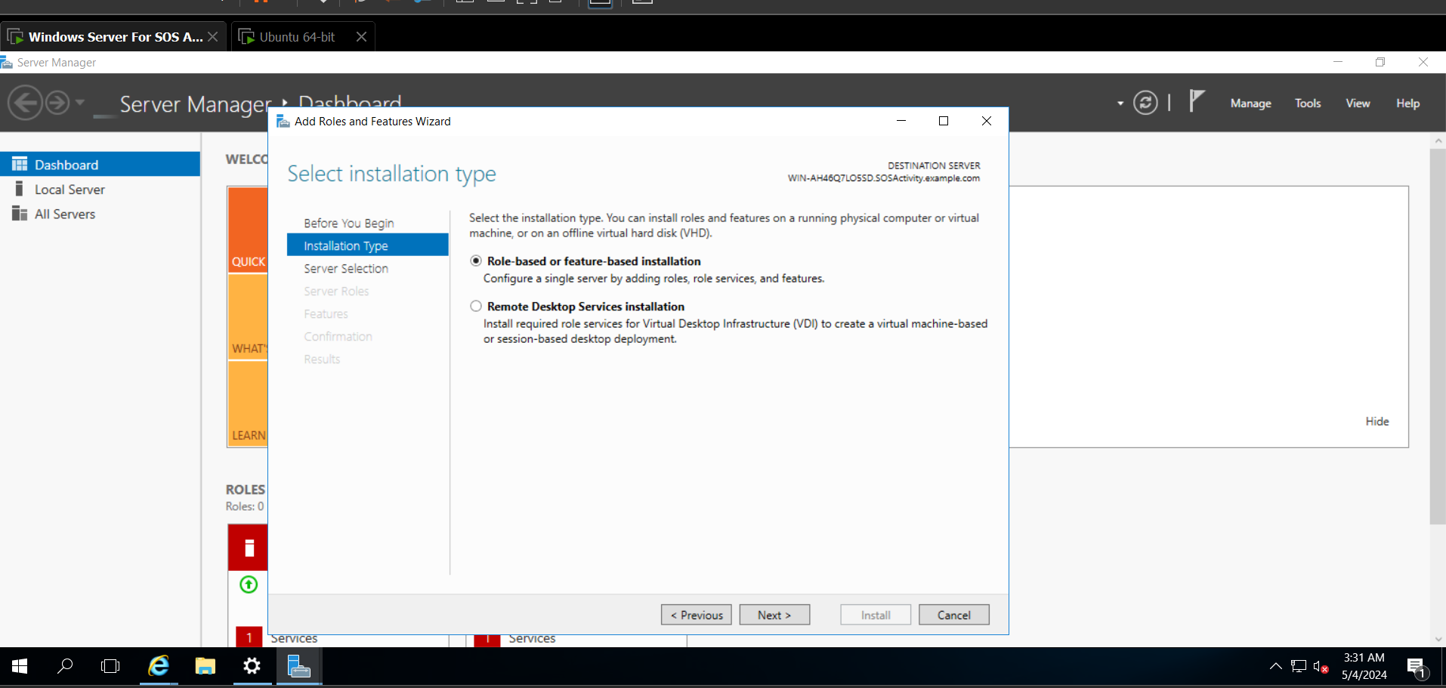

- Choose the appropriate server and navigate to "File and Storage Services."

- Check the box next to "Services for NFS."

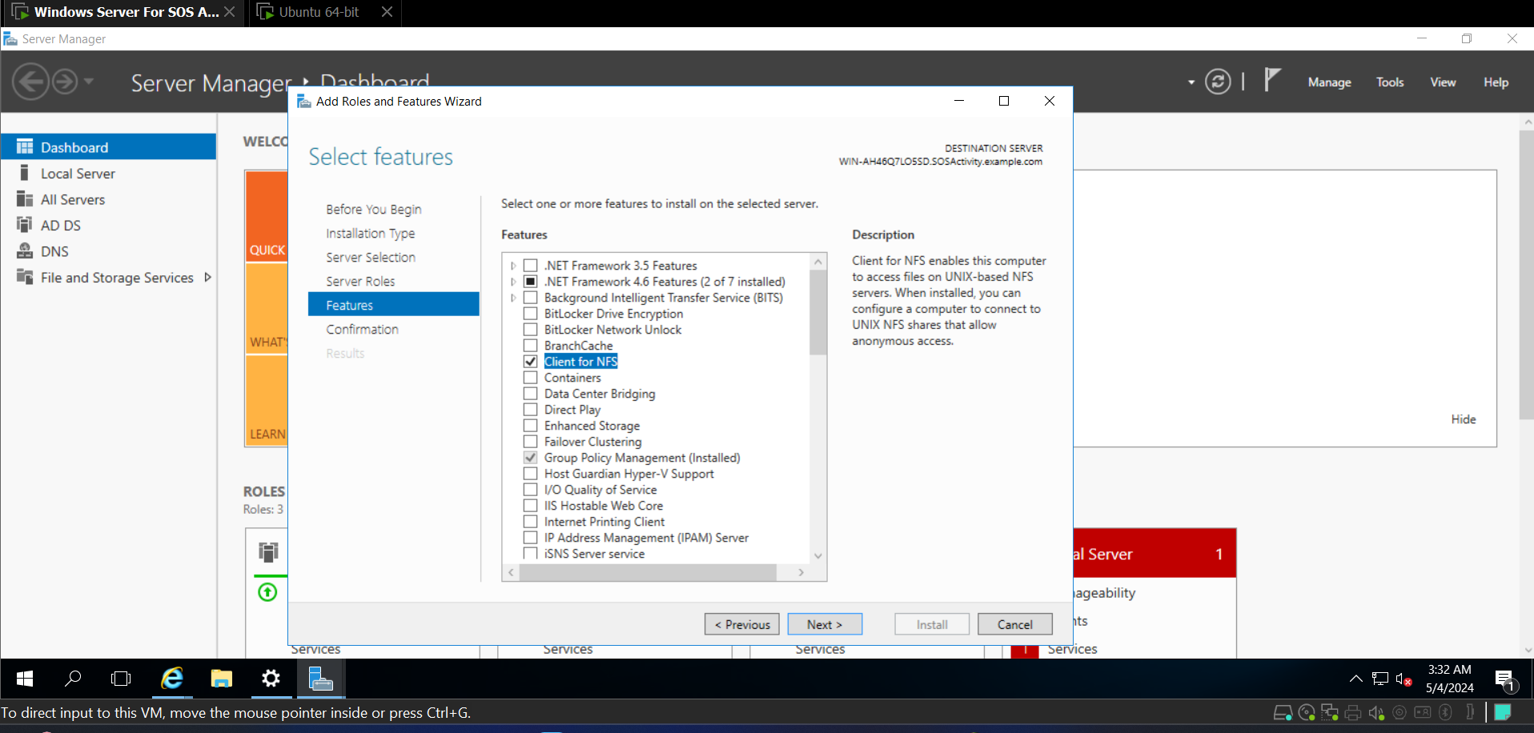

- Complete the wizard and wait for the installation to finish.

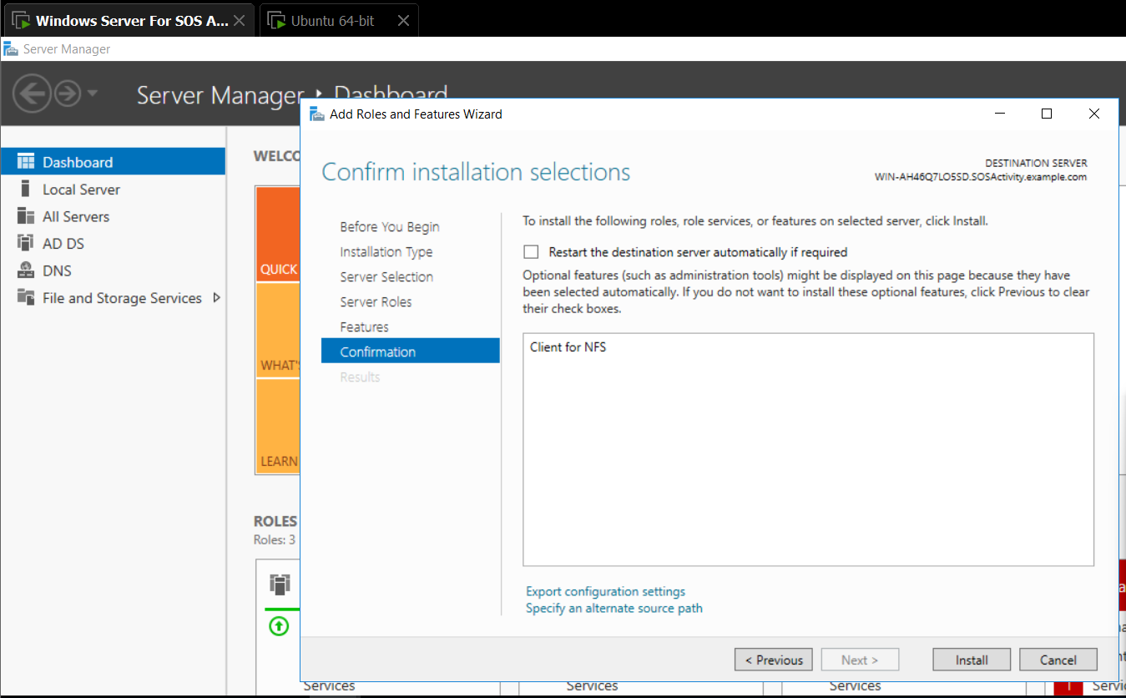

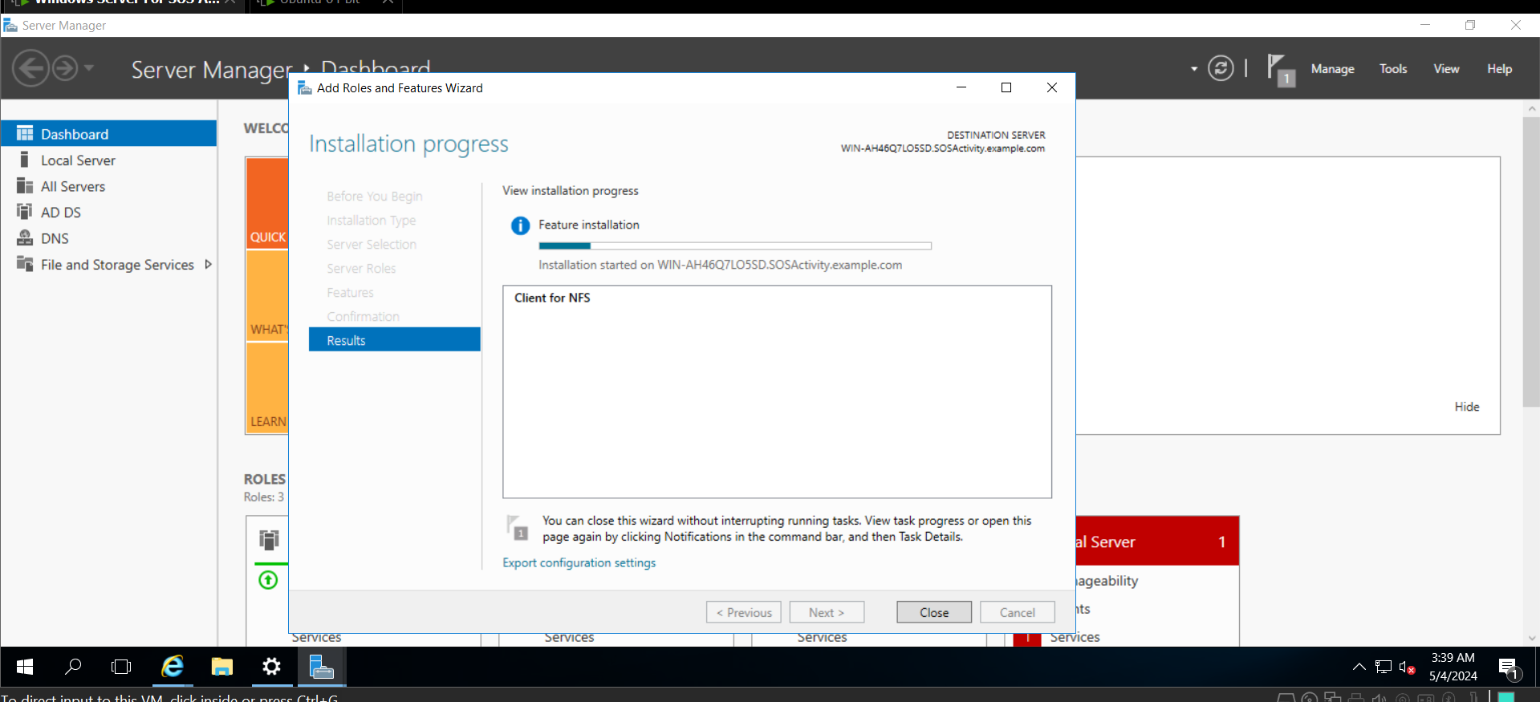

**Pinging from windows to linux machine and vice versa to check connection**

Use the command ping <windows ip> for pinging from LINUX to WINDOWS

Ise the command ping <linux ip> for pinging from WINDOWS to LINUX

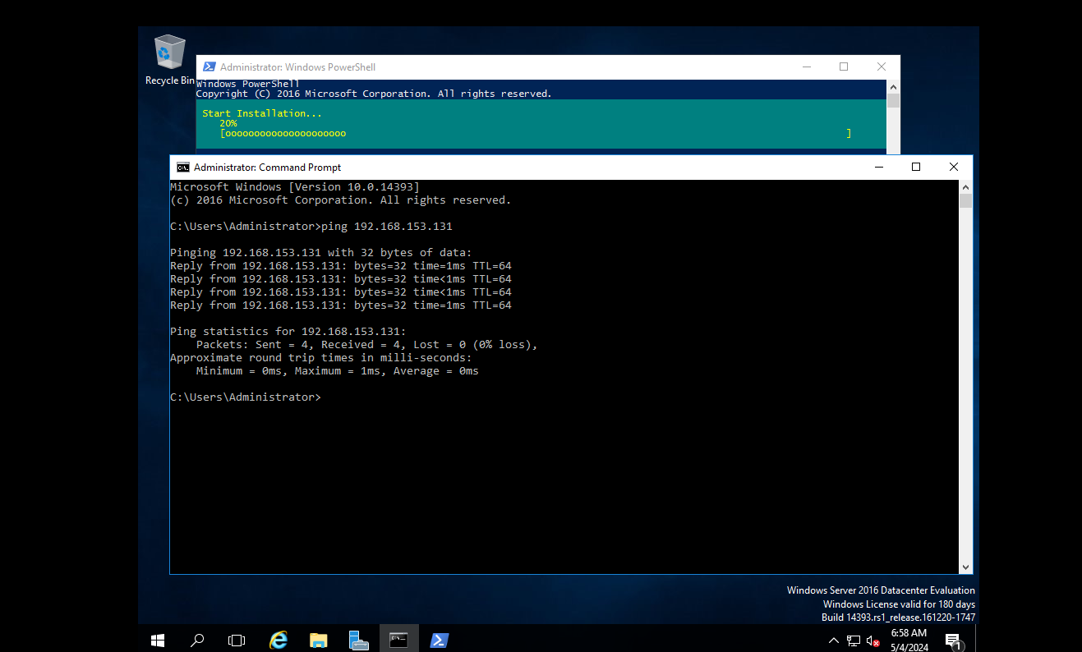

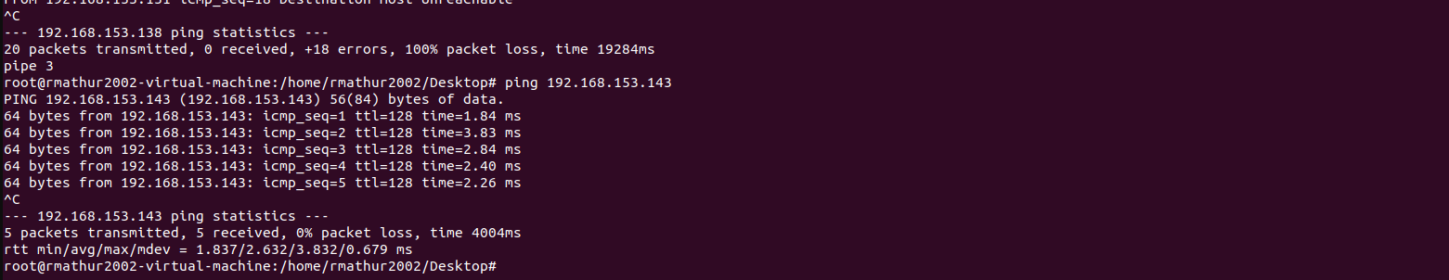

**Now in windows**

Open PowerShell as Administrator

Use the command “Install-WindowsFeature FS-NFS-Service”

Create a directory to share using the `New-Item` cmdlet. “ New-Item -ItemType Directory -Path C:\nfs_share”

Use the `New-NfsShare` cmdlet to create an NFS share. Specify the name and path of the folder you want to share. “New-NfsShare -Name nfs_share -Path C:\nfs_share”

Verify NFS Share “Get-NfsShare”

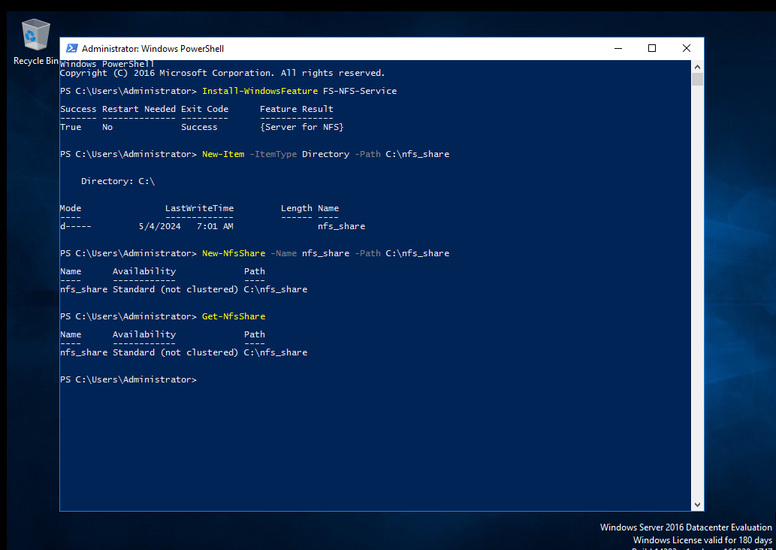

Copy some contents in the C:\nfs_share folder.

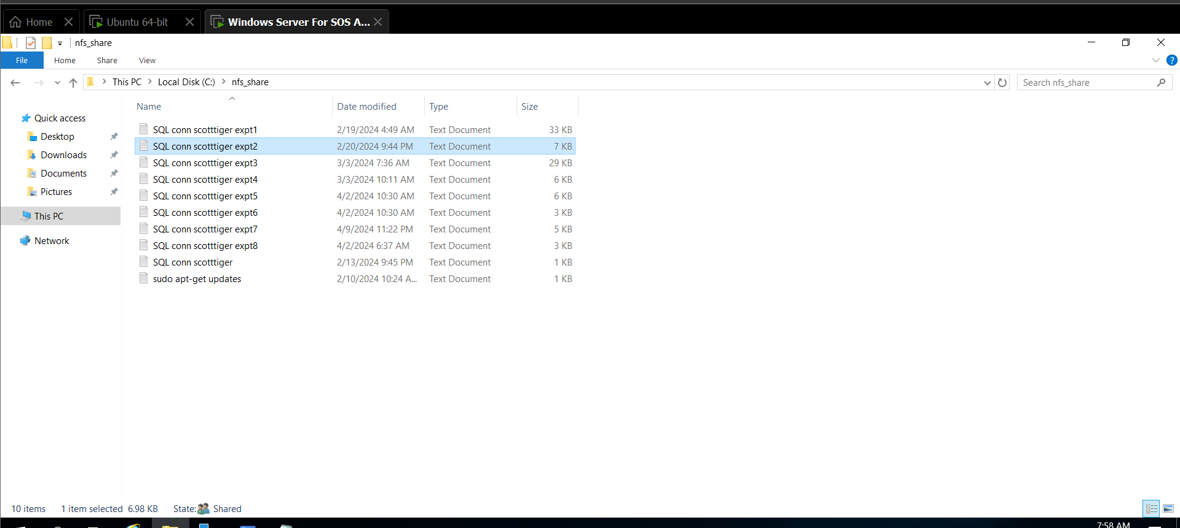

Now click on the Properties of the folder to be shared.

On the NFS Sharing tab click on the Advanced Sharing

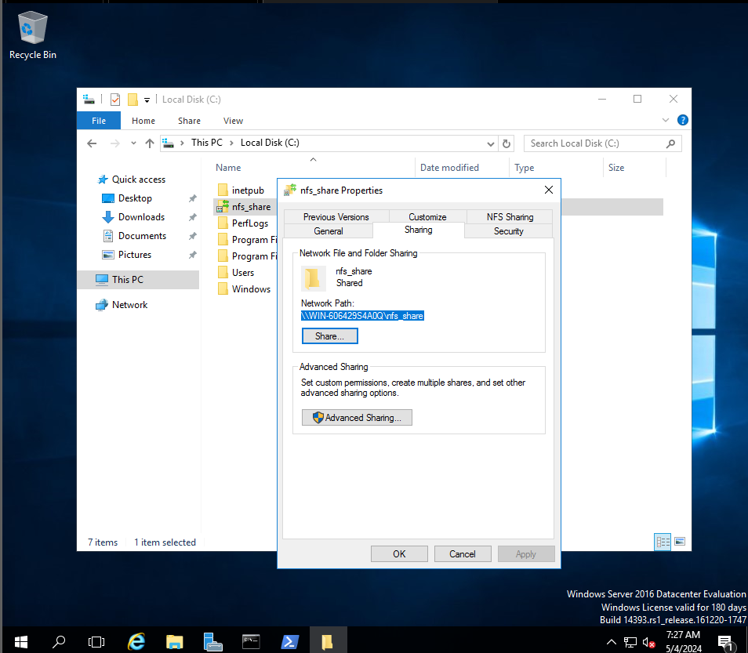

Check the Share this folder checkbox. And in permissions Type of access: give Read Write, and for everyone.

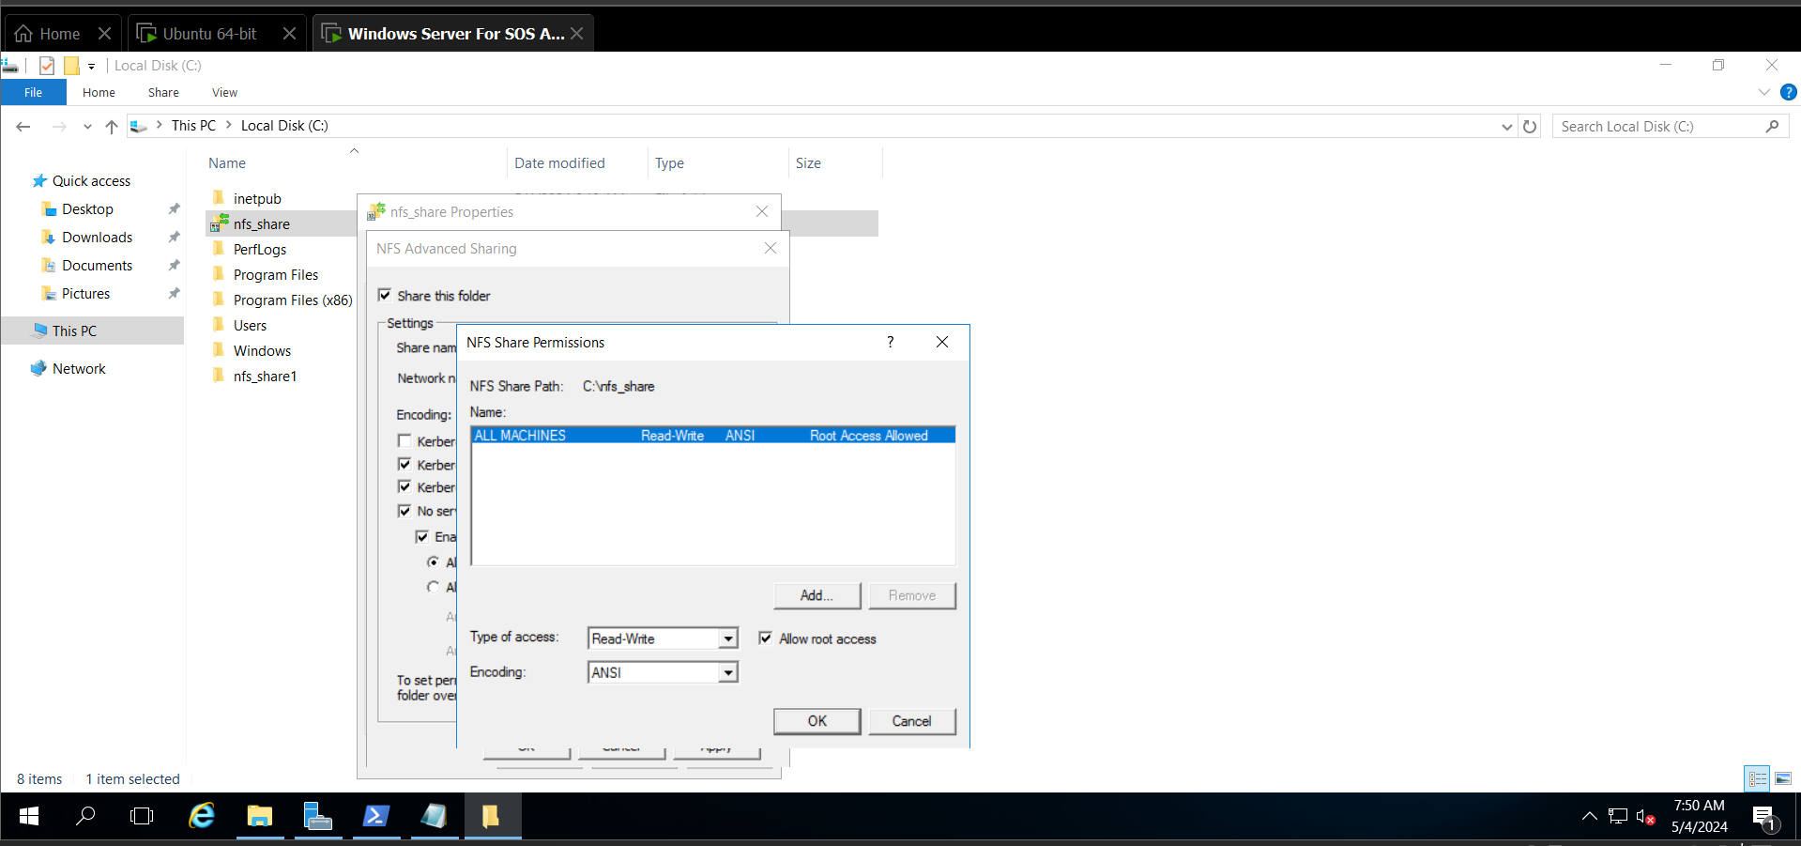

**Linux (Preinstalled)**

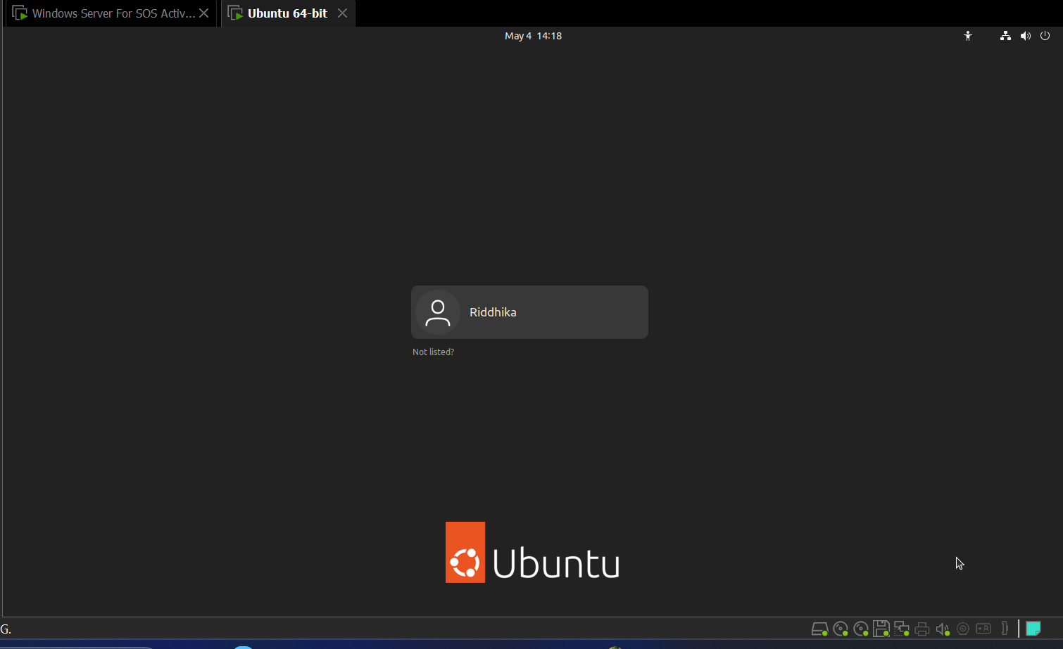

Enter into root user.

-Update the package repository:

sudo apt update

- Install the NFS client package:

sudo apt install nfs-common

sudo apt install nfs-kernal-server

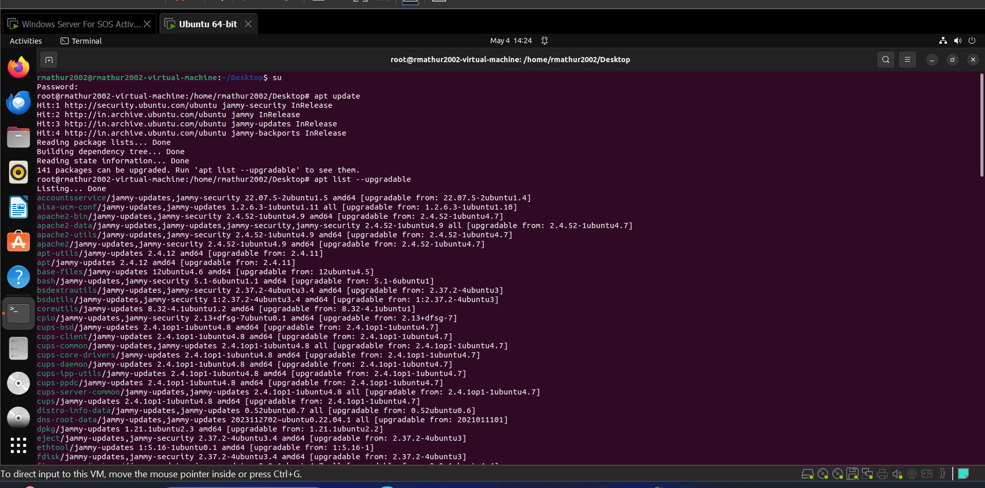

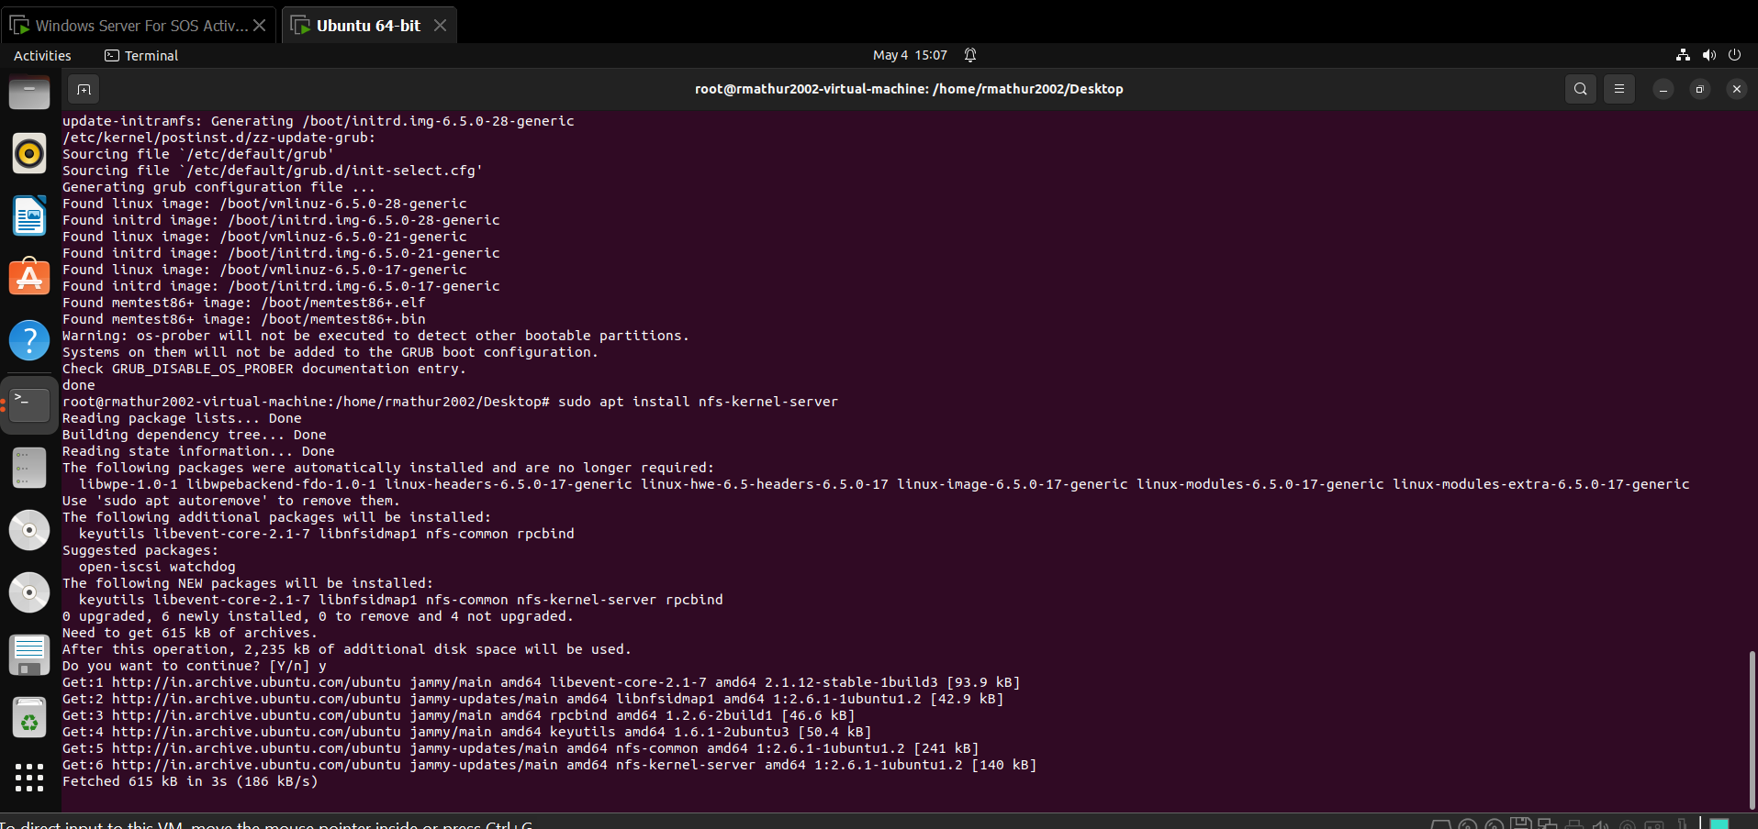

For nfs server we need windos machine and ubuntu machine ip address and pinging already checked

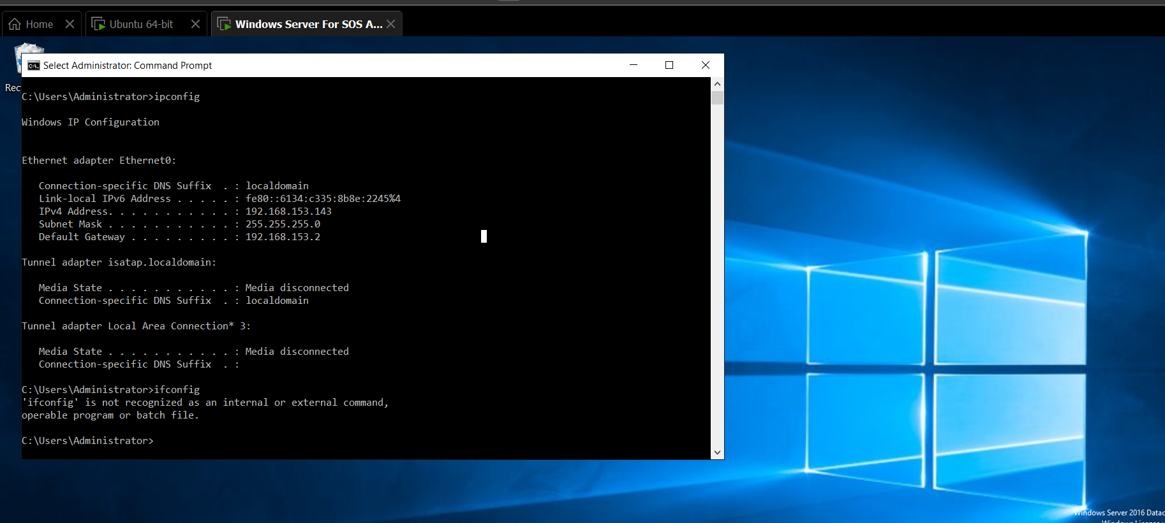

Overall - NFS INSTALLING AND MOUNTING AND ALL:_ COMMANDS

Open the terminal application on your Linux VM.

Create a directory where the shared folder will be mounted. For example:

sudo mkdir -p /mnt/nfs_backup_windows1

Install NFS Client Software (if not already installed)

sudo apt update

sudo apt install nfs-common

Use the `mount` command to mount the shared folder from the Windows Server VM:

sudo mount 192.168.153.143:/nfs_share /mnt/nfs_backup_windows1

To export a directory via NFS on Linux, you would add an entry to the /etc/exports file.

sudo nano /etc/exports

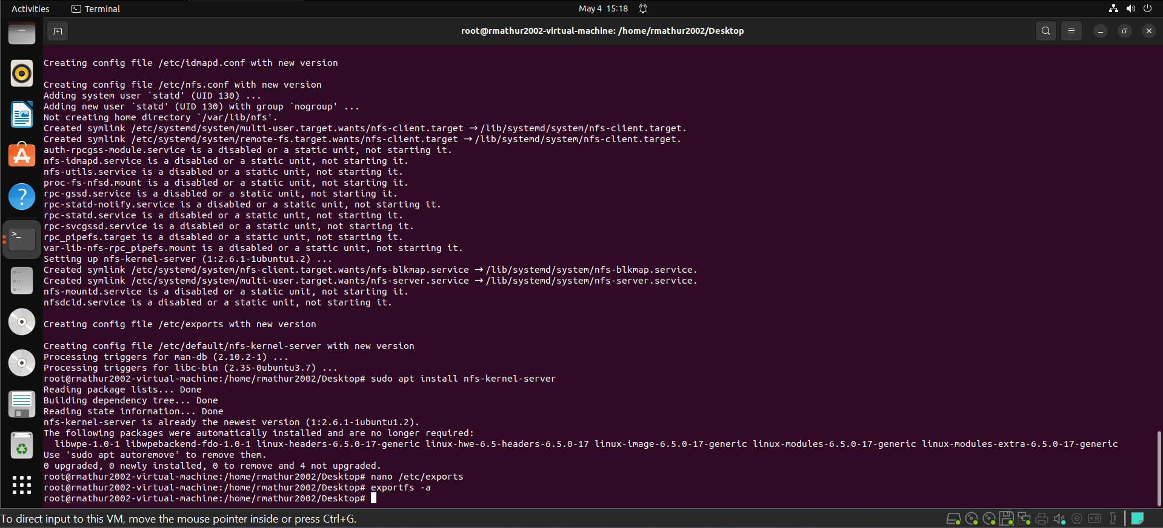

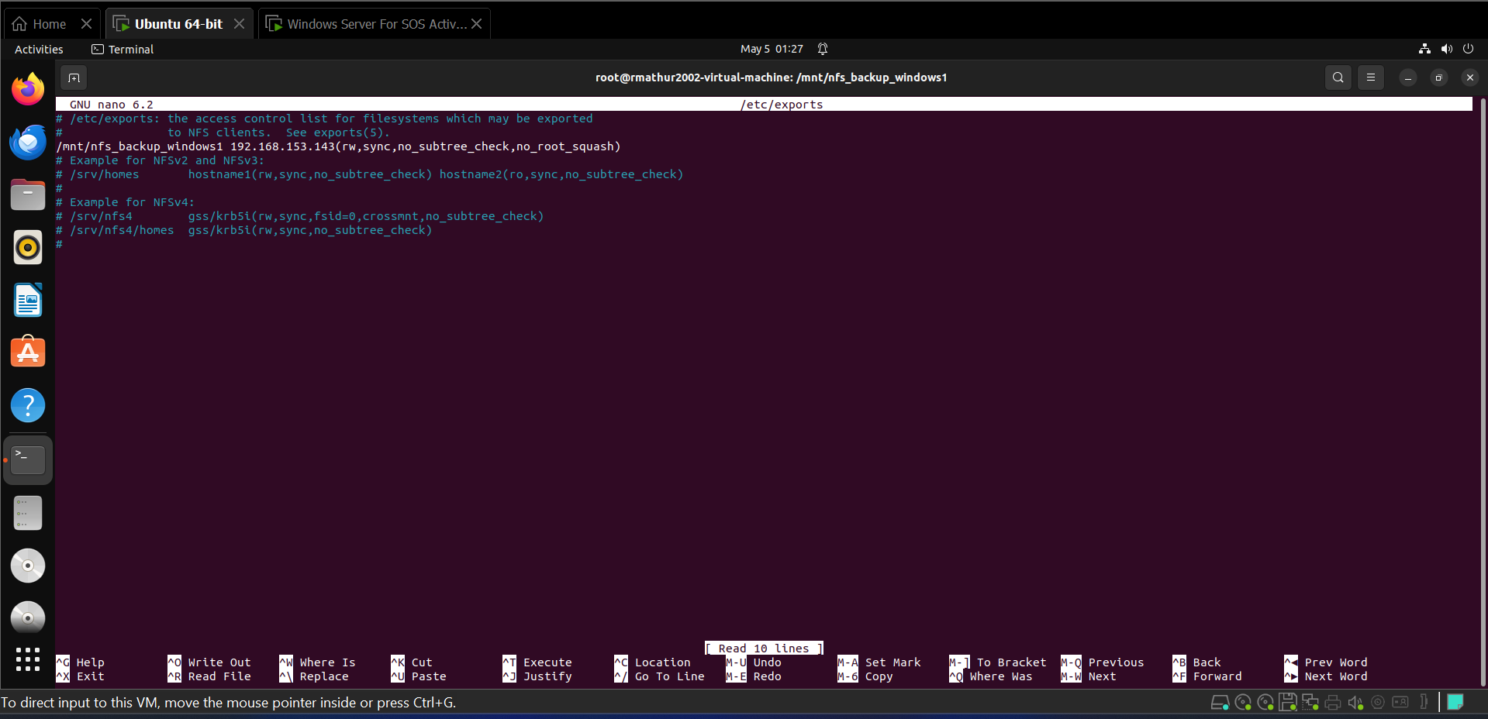

After adding the entry, save the file and exit the text editor. Then, you need to run the following command to apply the changes:

sudo exportfs -a

This command exports all directories listed in /etc/exports. If you only want to export specific directories, you can specify them instead of using -a.

Check if the NFS share is mounted correctly by listing the contents of the mount point:

ls /mnt/nfs_backup_windows1

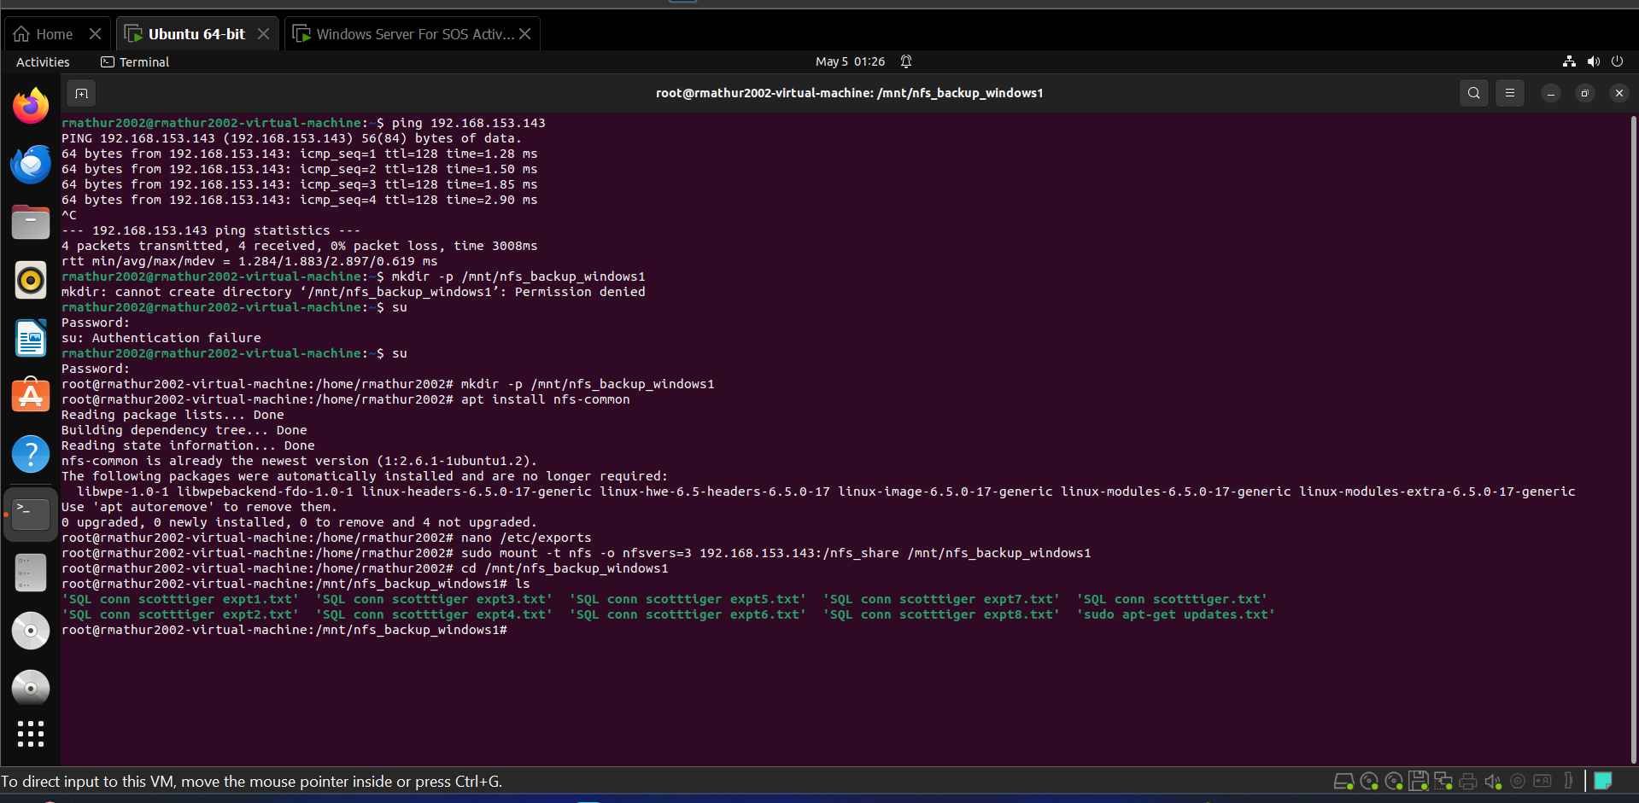

To automatically mount the NFS share at boot time, you can add an entry to the `/etc/fstab` file.

Open the `/etc/fstab` file in a text editor:

sudo nano /etc/fstab

Add the following line at the end of the file:

192.186.153.143:/nfs_share /mnt/nfs_backup_windows1 nfs defaults 0 0

Save the file and exit the text editor.

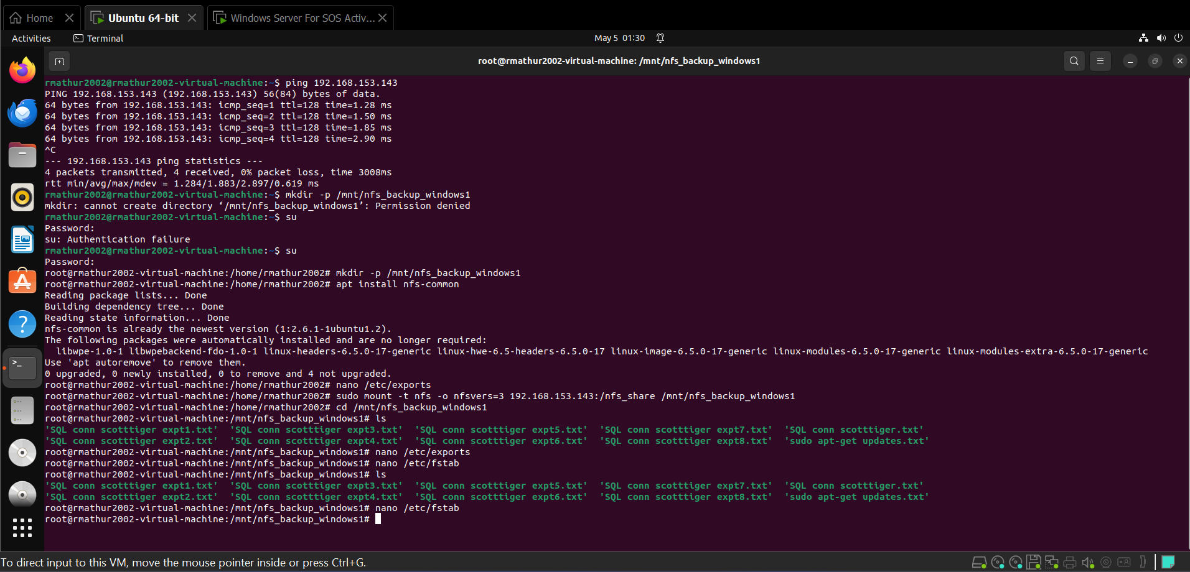

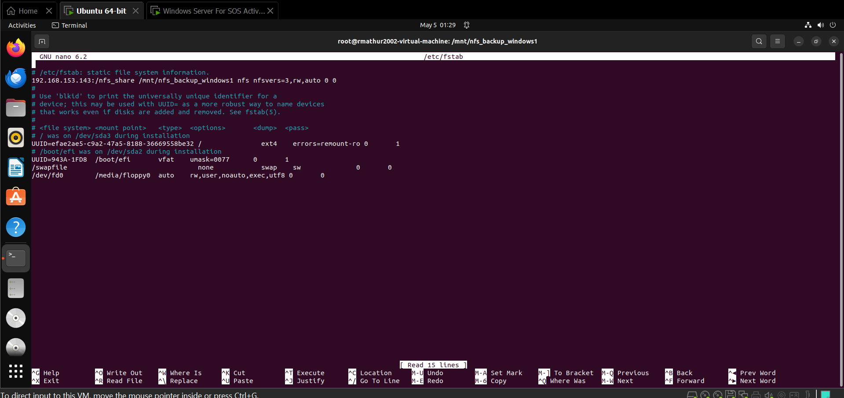

MOUNT ON A DIRECTORY IN DESKTOP

mkdir -p /root/Desktop/

ln -s /mnt/nfs_backup_windows1 /root/Desktop/nfs_backup_windows1

This will create the necessary directory and then create the symbolic link pointing to the mounted NFS share directory /mnt/nfs_backup_windows1.

ls -l /mnt/nfs_backup_windows1

This command will display a detailed list of files and directories within /mnt/nfs_backup_windows1, along with their permissions, ownership, size, and modification date.

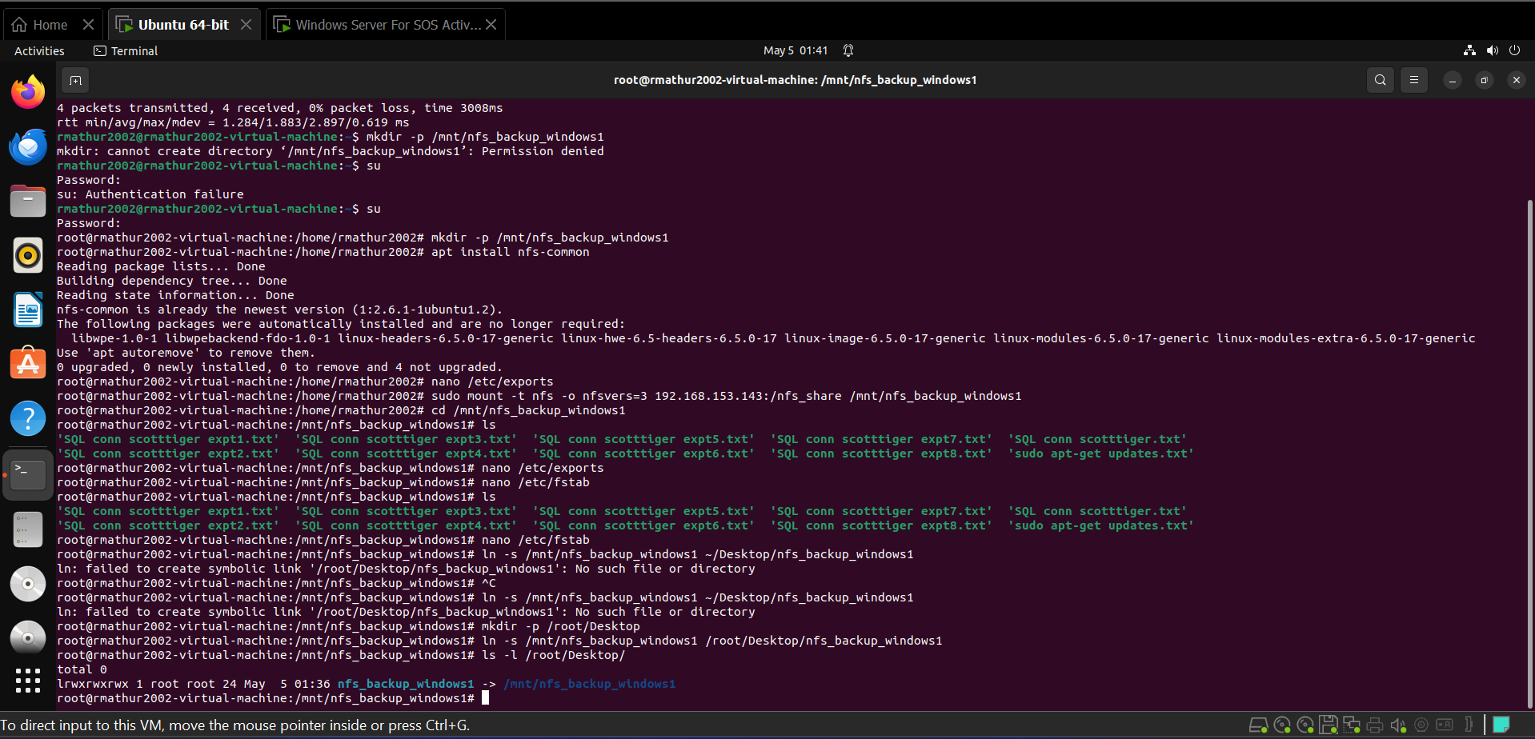

Dosktop folder visible but locked so no content will be seen.

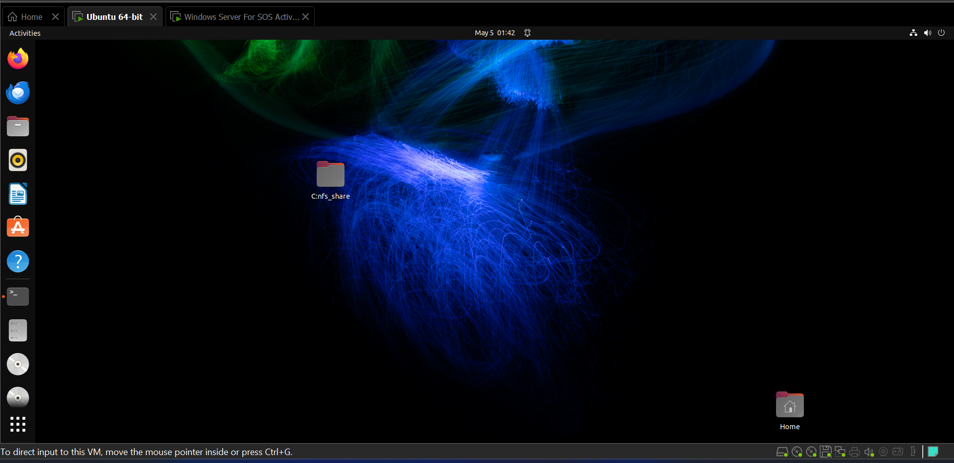

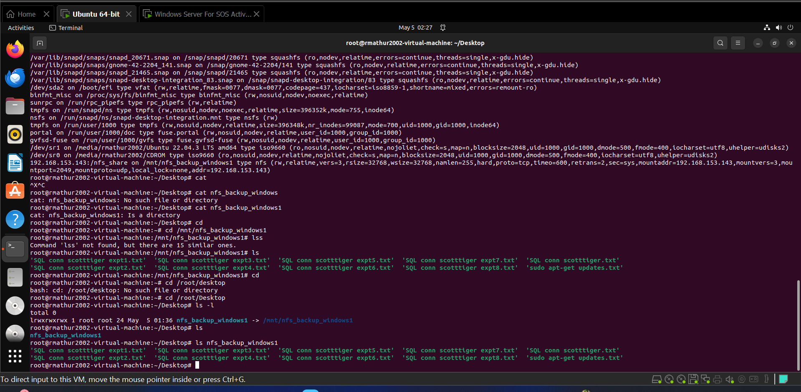

In root user we can see the content of the files

cd /root/Desktop/nfs_backup_windows1

ls – shows the content of directory

cat “file name”

